|  |  |
| --- | --- |
| **RTC Deliverable Reference No. (Work Item #)** | 186911 |
| **RTC Design Reference No. (Work Item #)** | 186899 |
| **Owner** | < Sarit Seal > |
| **Author** | < Sarit Seal, Ramdas Gawande, Keshavan Narayanan, Renju Damodaran, Anthony Goddard > |
| **Version** | 1.02 |
| **Approval Date** |  |

Document Revisions

| **Date** | **Author** | **Role** | **Version** | **Comments** |
| --- | --- | --- | --- | --- |
| 12/06/2014 | Sarit Seal | Solution Architect | 0.1 | Draft |
|  | Sarit Seal | Solution Architect | 0.2 | Released to ADM teams |
| 31.Aug.2014 | Sarit Seal | Solution Architect | 0.3 | Incorporated the low volume file solution |
| 01.Sep.2014 | Renju Damodaran | Security Architect | 0.31 | Incorporated the security view of the solution |
| 02.Sep.2014 | Ramdas Gawande / Sarit Seal | Solution Architect | 0.32 | Incorporated feedback comments from ADM Payments |
| 04.Sep.2014 | Ramdas Gawande / Sarit Seal ; Anthony Goddard | Solution Architect and Infrastructure Architect | 0.33 | Incorporated Infrastructure section  Architecture decision  Changes to Interfaces |
| 04.Sep.2014 | Keshavan Narayanan | Information Architect | 0.34 | Incorporated Data view |
| 05.Sep.2014 | Keshavan Narayanan, Ramdas Gawande / Sarit Seal, Anthony Goddard | Information Architect , Solution Architect and Infrastructure Architect | 0.35 | Incorporated changes to data view, infrastructure view and moved to the latest AD template |
| 08.Sep.2014 | Sarit Seal | Solution Architect | 0.36 | * Incorporated formatting comments from Anthony * Removed the direct interface between Accounting Hub and IF Lynx from the Outline Application View * Asumption 6 Added * Point 12 Page 18 Reworded * Point 12 Page 7 Note added for SDEP * Architecture Decision Added (ID:321) * Added the File Solution decision email (refer References Section) |
| 09.Sep.2014 | Sarit Seal | Solution Architect | 0.37 | Incorporated comments from David Walsh  Page 9, Column Data to be Exchanged; Row Transaction bus; last paragraph elaborated on TODS interface from Accounting Hub  Page 14 Point 5, details of HOCA incorporated  Page 33 Paragraph 2 Note added  Page 43 TODS row added  Page 21 process batch posting outbound posting file – diagram modified. Two activity names reworded – Comments from Shantanu  Comments from Rohit:  Page 29 Paragraph 4 clarified batch functionality on Transaction Bus  section 3.1.1 changed to 2.4.2  Purpose of the document Point 6 updated |
| 10.Sep.2014 | Sarit Seal | Solution Architect | 0.38 | Addressed Vinoth’s comments  Page 17 Last paragraph – Standin for NPA postings Reworded to include Standin flag in AMD  Page 21Last paragraph till the first 4 paragraphs on Page 22 |
| 11.Sep.2014 | Sarit Seal | Solution Architect | 0.39 | Activity diagram changed “Retrieve Account Location - Using OCIS and ALS” |
| 11.Sep.2014 | Sarit Seal | Solution Architect | 0.40 | Datacache removed for OCIS and ALS data. Architecture decision modified  Warren’s comments incorporated |
| 19.Sep.2014 | Sarit Seal | Solution Architect | 1.01 | Diagrams changed in section 3.1 and aligned to the Application change legend |
| 22.Sep.2014 | Sarit Seal | Solution Architect | 1.02 | Hugh Comments:  Spellings and grammer checked  Document reference number changed  wCBS location updated in Infrastructure section  LBG IT Workload Placement Principles added in compliance  SRF updates in identity management and fraud and financial crime sections |

Document Contribution

| **Date** | **Name** | **Role** | **Version** | **Contribution** |
| --- | --- | --- | --- | --- |
| 05.Sep.2014 | Sarit Seal | Application Architect | 0.36 | Overall |
| 05.Sep.2014 | Anthony Goddard | Infrastructure Architect | 0.35 | Infrastructure |
| 05.Sep.2014 | Keshavan Narayanan | Information Architect | 0.35 | Data |
| 01.Sep.2014 | Renju Damodaran | Security Architect | 0,31 | Security |
| 05.Sep.2014 | Ramdas Gawande | Application Architect | 0.35 | Interfaces to product platforms |

Distribution List

| **Date** | **Name** | **Role** | **Version** | **Reason for Issue** |
| --- | --- | --- | --- | --- |
|  | Deshdeep Saxena | Business Analyst |  | Explanation of the solution |
|  | Alister Lees | IT Project Manager |  | Explanation of the solution |
|  | Stuart Mason | Senior SME |  | Explanation of the solution |
|  | Vinoth Krishnamoorthy | Accounting Hub DA |  | Explanation of the solution |
|  | Ankit Somani | ADM Subject Matter Expert <Account Master Data> |  | Explanation of the solution |
|  | Wayne Ramsey / Kirstie Elliot | ADM Subject Matter Expert <IF-TD01> |  | Explanation of the solution |
|  | Nick Simon-Norris | ADM Subject Matter Expert <IF-Lynx> |  | Explanation of the solution |
|  | (via Fraser Lyle) | ADM Subject Matter Expert <IF-Midtier> |  | Explanation of the solution |
|  | Isabel Taggart / Peter Niccol | ADM Subject Matter Expert <NCA and wCBS> |  | Explanation of the solution |
|  | Wayne Ramsey / Kirstie Elliot | ADM Subject Matter Expert <TD01> |  | Explanation of the solution |
|  | Anshu Maheshwari | Quality Assurance (Functional) |  | Explanation of the solution |
|  | Anshu Maheshwari | Quality Assurance (Non-Functional) |  | Explanation of the solution |
|  |  | Release Manager |  | Explanation of the solution |
|  | Martin Allen | SD Infrastructure Solution Manager |  | Explanation of the solution |
|  | Shantanu Joshi | SME Transaction Bus |  | Explanation of the solution |

Table of Contents

1. Project Summary 5

2. Requirements View 6

2.1 Use Case Diagram 6

2.2 Non-Functional Requirements 6

2.3 Requirements Traceability 6

2.4 Business Impact Assessment (BIA) 7

3. application view 8

3.1 Outline Application View 8

3.2 Detail Application View 8

3.3 Sequence Diagrams for all Use Cases 8

4. Data View 9

4.1 Outline Data Elements 9

4.2 Detail Data Elements 9

5. Infrastructure View 10

5.1 Outline Infrastructure Elements 10

5.2 Detail Infrastructure Elements 12

5.3 Environment Overview 17

6. Cross-Cutting views 18

6.1 Security 18

6.1.1 Security Domain Impact Analysis 18

6.1.2 Security Model for Impacted Domains 18

6.2 Identity Management 20

6.3 Application Security 22

6.4 Fraud and Financial Crime 24

6.5 Information Privacy 25

6.6 Compliance 26

6.7 <Other Cross-Cutting Views as Required for the Project> 27

7. Architecture Decisions 28

8. Appendices 29

8.1 IT Application Landscape Overview: Application Change Inventory 29

8.2 Compliance with Lloyds Banking Group Policies and Regulatory Requirements, IT Policies, Standards and Patterns 30

8.2.1 Compliance with Policies, Regulations, Standards and Patterns 30

8.2.2 Group Records Policy Compliance 30

8.3 Known Architecture Risks, Assumptions, Issues and Dependencies 31

8.3.1 Risks 31

8.3.2 Assumptions 31

8.3.3 Issues 31

8.3.4 Dependencies 31

8.4 references 32

**Purpose of the document**

The Architecture Description is a deliverable that is produced after the Detail Architecture Elements activities in the Group’s High Level Design process. It uses several architectural views to depict different aspects of the system. It defines the required components, their interfaces and the nodes on which they will execute so that development and configuration of the system can begin.

It is produced when the architect deems that the artefacts are sufficiently detailed to pass to Application Development and Maintenance (ADM) and Service Delivery (SD) for build and test.

This document is an extension of the earlier E2E document (Accounting hub for TBT SOC approved on 17th Dec 2013) produced for Accounting Hub Phase1 and Phase 2. Reasons for creating a new document

1. Align to the industrialized design process
2. Align to the Posting requirements from the hHBOS Payment engines. The Payment traffic will be routed to the Lloyds Payment engines, and will be posted to wCBS, IF-TD01, IF-Lynx, TD01, NCA
3. Align to the revised accounting model which includes settlement/contra NPA’s on rCBS accounts while the customer accounts remains in the hHBOS platforms.

Posting to NCA, is to enable posting to accounts such as Sainbury’s which will be removed by subsequent project

Batch Postings to hHBOS platforms. Batch files will be generated by Accounting hub 🡪 Transaction Bus for the hHBOS platforms.

Accounting Hub will also receive Batch files from the Payment engines for Paper clearings and potentially BACS, and it would generate the posting files for each product platforms. However this is not covered in this AD. A separate document will be created to cover this requirement.

Guidance notes and assistance in the architectural method are available on the High Level Design area of Compass, where samples and templates for the standardised design artefacts can be found. The constituent diagrams and tables must be used to clearly represent the solution, keeping text to a minimum.  Where it has been deemed unnecessary to include a design artefact a rationale must be included in the appropriate section.

# Project Summary

A Technical problem was experienced by the Royal Bank of Scotland Group (RBSG) in mid 2012. Following the problem Group Operations Risk, supported by Group IT, initiated The IT Resilience Review with the purpose of identifying the IT resiliency of LBGs Critical Business Processes (CBPs). Price Waterhouse Coopers (PwC) was invited to conduct an independent review of the IT resiliency of LBG’s CBPs and identified 36 CBPs categorised as either Category A, B and C with different availability and recovery time objectives across 19 key themes. One of the key themes was Age and Complexity and this project is one of a number that will reduce the resilience risk associated with the identified CBPs.

This project is required as an enabler for up to 5 other projects within the Age & Complexity theme - CHAPS, Faster Payments, International, cheque and credit In Clearing and BACS projects. All projects were identified in the Technology Simplification Initiative's scoping phase and are specifically in the Payments (Routing) area. The direction is the Payments engines in the HBOS legacy will be decommissioned and the traffic will be routed to the Lloyds Payments engines (a.k.a LCS, STP etc). As per strategy Payments engines will not directly send the postings to the hHBOS product platforms, rather the postings and enquiry requests will be mediated through Accounting hub. Hence the interfaces to the product platforms are being built in Accounting Hub.

The strategy is to use Accounting hub as a facade for the product platforms both for account enquiry and account posting. To the external consumers. It also acts as a gateway to the product platforms as it hides the complexity of the consumers, schemes, and transactions. This strategy benefits the programme by abstracting the payment engines from the product platforms. Hence there is a potential case of re-use. The programme benefits through economies of scale.

Accounting hub will be delivered as part of TMH Release 4 and release 5.1 into production. These releases will deliver the capability to post to rCBS and provide enquiry facility for rCBS, CAP and Common System accounts.

The scope of this project is to build the interface to the HBOS product platforms. The interface built will be a generic interface to the product platforms. The actual posting entries will be decided by the payment engine projects which will use Accounting hub capability to post to these product platforms. The guideline is to keep the design generic for it to accommodate accounting models based on the current Faster Payment Scheme (FPS) accounting model for accounts on hHBOS.

As per the HBOS decommissioning project under Technology Simplification Age & complexity the scope is to decommission the hHBOS Payment engines and route all the inbound and out-bound payments through the Lloyds payments engines. The Lloyds Payment engines (aka LCS, Common System, STP) will use Accounting hub to identify the product platform, and will route to accounting hub for posting to the hHBOS product platforms. The primary guideline is to reuse the existing interfaces on the hHBOS platforms this approach reduces development on the fated systems.

Provide a description (Executive Summary) of the project. This must be no more than half a page.

# Requirements View

This section describes, at a high level, the current system and how the solution will meet the requirements for the new system. It bounds the scope of the system to be constructed or changed and identifies the scope of change to be delivered by the project. It provides a quick insight into system-to-system integration changes that this project will need to deliver.

## System Context Diagram: As-Is

The current system context does not include Accounting Hub. The system in context is Accounting Hub it does not exist in the current architecture. As per the current implementation the payment engines connect directly to the accounting platforms for Posting and enquiries. Account Lookup Service - Migration Services (Troux ID: AL04033) (*will be referred as “ALS”)* plays an important role as it is used to identify whether the account is migrated to Lloyds or is an un-migrated account residing in the hHBOS product platforms. *The current system context does not include Accounting hub. The Payment engines make postings to the Product platforms directly.*

*The payment engine projects aka CHAPS and International Projects will explain the current System context and the to-be system context with Accounting Hub meditating the account enquiry and postings to the product platforms.*

## Systems Context Diagram: To-Be

This diagram must be provided for all projects. See Hint and Tip RSA Diagrams – Copying or Saving.

The following context diagram depicts the to-be system context. The system in context is the Accounting Hub.

Core capabilities to be delivered as part of this project is to establish connectivity to the hHBOS product platforms. These interfaces will be both batch and online.

The accounting model pattern is based on the FPS model used today. The FPS model sends the customer advices to the hHBOS platforms while it sends a settlement entry to rCBS. The design does not constrain on the accounting model patterns. In order to integrate with the hHBOS platforms. Accounting Hub needs the account posting entries, however the actual entries are out of scope for this project. The payment projects under resilience will be responsible to create / document and get the required approvals for the accounting models. Additionally these posting entries will be loaded in Account Master Data (AMD) within the scope of the payment scheme projects. (Ref: Point 1 Dependencies section below )

AMD will maintain some additional reference data required during message transformation. These will be used to populate the message before sending to the product platforms.

Note: Throughout the document the message will be used to refer both for files or individual messages. For files secured C:D will be used to transfer the files to the hHBOS platforms. The online interface will be delivered through messages sent over MQ.

This is an extension to the design and the code delivered for accounting hub as part of TMH release 4 and 5.1

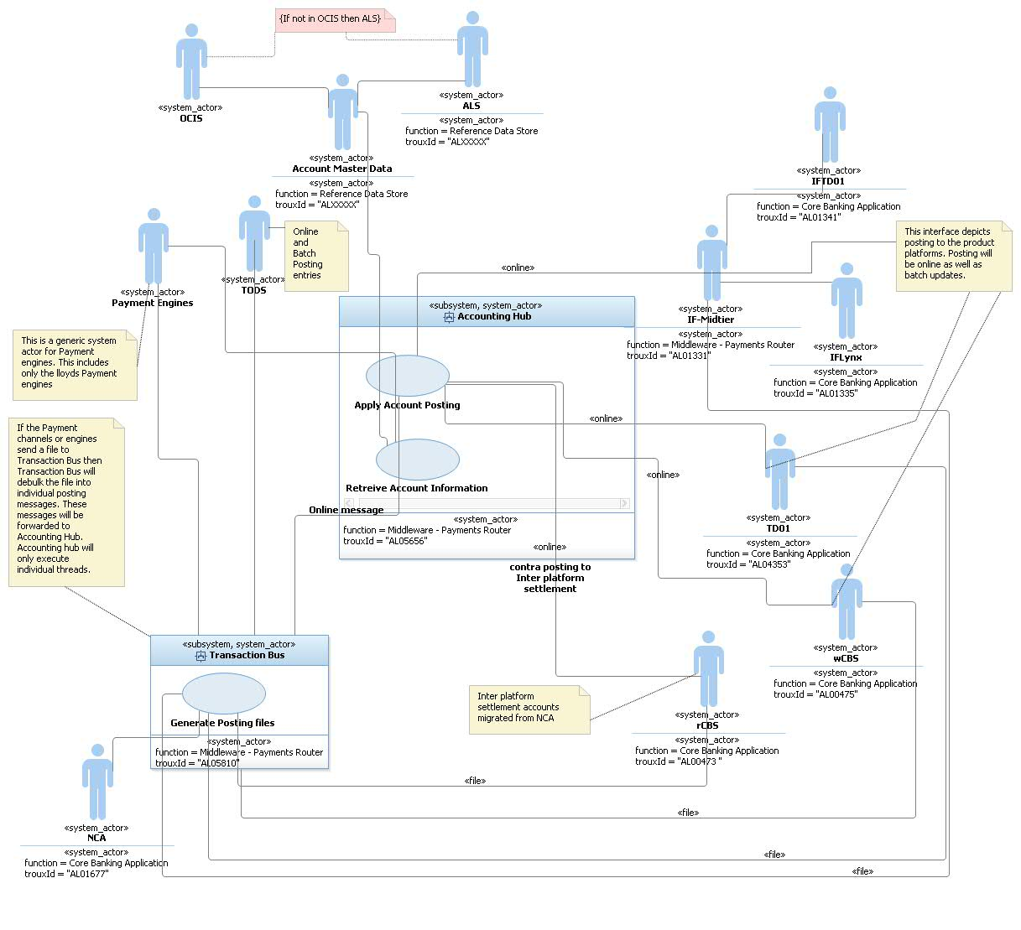

| No | From System | To System | Description | Data to be exchanged | Complexity |
| --- | --- | --- | --- | --- | --- |
| 1*1* | Transaction Bus | Accounting hub : Apply Account Posting  (online only) | Pass the posting transactions from Transaction Bus to accounting hub. These are real-time requests to Accounting Hub. Accounting Hub will generate the actual posting entries and pass to the product platforms. The responses will be sent to the Transaction Bus. | Transaction bus (FTM) will send the Posting request to Accounting Hub. The message will be based on the IFW format and will be wrapped in a SOAP envelop.  Accounting Hub will respond with a response message based on the IFW format and wrapped in a SOAP envelop. This response is for the status of the request  The hHBOS product platforms needs account Posting files from Accounting Hub. Transaction Bus will deliver the file bulking functionality. Accounting hub will send the posting entries to Transaction Bus. Transaction bus will bulk the entries and either on schedule or on a control message from Accounting hub the files will be physically generated and sent to the hHBOS product platforms.  Assumption: If a Payment engine or channel sends Postings file to Transaction Bus. Transaction bus will debulk the file into individual posting messages and send to Accounting Hub. Accounting Hub will be responsible to post to the hHBOS product platforms and send the response back to Transaction Bus. Transaction Bus will be responsible to replicate the data in TODS.  The functionality on Transaction Bus. The expectation is to move to the strategic approach of using pub-sub. Transaction Bus writes to a topic end point. TODS will store the individual postings and also a reference to the file where the posting is collected. | Medium to Low.  This interface will be live as part of TMH release 4.  Data: The inbound message format may undergo a change. The details of the change will be documented in the Accounting hub Interface document.  Security: The MQ Queues will be accessed over a SSL’ised connection. The message will not be encrypted.  Infrastructure: The solution does not expect any changes on the hHBOS product platforms. The data volumes will remain the same as it is today. The interface mode will remain as-is. |
| 2 | Payment engines  (This is used as a placeholder for enquiries from Payment engines to Accounting hub) | Accounting hub | There are two possible interfaces:   1. Account enquiry for all hHBOS accounts. The current scope | Account Enquiry – Sort Code + Account Number  The scope of this AD only covers for identifying the product platform for the incoming Sort code and Account number. Provision exists within Accounting Hub for account status and balance. This project will not be delivering the status and balance as there are no requirements from the payment workstreams | Account Enquiry: None |
| 3 | Accounting hub: Apply Account Posting | Account Master data | Identify the product platform by sort code + account number | This is a SOAP web service call over HTTPS. The request will contain sort code+ account number while the response will contain the product platform identifier | Proposed change: Account Master data will build a service to identify the product platform apart from the current functionality covered as part of the Retrieve Additional Account Information.  Refer §2.4.2 for more details  This includes new interface to OCIS from AMD  The current AMD design connects to ALS and RLS(BACS Report Gateway) |
| 4 | Accounting hub: Apply Account Posting 🡪 Transaction Bus (Posting File Generation) | NCA | Posting entries for customer accounts on NCA and settlement entries  The file bulking functionality will be delivered by Transaction Bus. | This can be both a file and online through NCA. | No impact on NCA. Accounting hub will send the files to NRT Proxy through Transaction Bus. Accounting hub will generate the NCA postings and Transaction Bus will bulk the entries before sending to the Product platform  !! Medium to High 🡪 Transaction Bus, the file bulking functionality needs to be built  $$ Accounting Hub will have a component to send the entries to Transaction Bus for Posting entries to be bulked in files and sent to the product platforms. It will also manage the Transaction Context with the online entries which it sends directly to the Product platforms as well as posting entries which are sent as files through Transaction Bus |
| 5 | Accounting hub: Apply Account Posting 🡪 TD01  Accounting hub: Apply Account Posting 🡪Transaction Bus (Posting File Generation) 🡪 TD01 | TD01 | Posting entries for customer accounts on TD01 for all payment schemes | This will be both file and online. For example CHAPS will be a MQ message, while for international it will be files | No impact on TD01.  CHAPS: Accounting hub will have to generate MQ messages for TD01 Online to consume  Accounting Hub will generate the International posting files leveraging the file bulking capability of Transaction Bus  BACS and Clearings will be files outside the scope of this AD |
| 6 | Accounting hub: Apply Account Posting 🡪 wCBS  Accounting hub: Apply Account Posting 🡪Transaction Bus (Posting File Generation) 🡪 wCBS | wCBS | Posting entries for customer accounts on wCBS for all payment schemes | This will be both file and online.  For example CHAPS will be a MQ message, while for international it will be files | No impact on wCBS.  CHAPS: Accounting hub will have to generate MQ messages for wCBS Online to consume  Accounting Hub will generate the International posting files leveraging the file bulking capability of Transaction Bus  BACS and Clearings will be files outside the scope of this AD  Please refer points tagged as !! and $$ in the above cell |
| 7 | Accounting hub: Apply Account Posting | IF-Midtier/IF-TD01 | Posting entries for customer accounts on IF-TD01 for all payment schemes.  Send the message to IF-Midtier, and IF-Midtier forwards to IF-TD01 Reuse the functionality as it exists today | This will be both file and online.  For example CHAPS will be a MQ message, while for BACS it will be files | No impact on IF-Midtier and IF-TD01.  CHAPS: Accounting hub will have to generate files for IF-Midtier  International will be files  Please refer points tagged as !! and $$ in the above cell |
| 8 | Accounting hub: Apply Account Posting | IF-Midtier🡪 IF-Lynx | Posting entries for customer accounts on IF-Lynx for all payment schemes.  Accounting Hub will route to IF-Midtier, and IF-Midtier forwards it to the IF Platforms  Reuse the functionality as it exists today | This will be both file and online.  For example CHAPS will be a MQ message, while for BACS it will be files | No impact on IF-Lynx.  CHAPS: Accounting hub will have to generate MQ messages for IF-Midtier/ IFLynx  International will be files  Please refer points tagged as !! and $$ in the above cell |
| 9 | Accounting hub: Apply Account Posting | rCBS | Settlement entries for customer postings for all payment schemes. This can be both individual contra postings or aggregated contra postings | This will be online.  If the accounting model given by the Payment project work-streams expect the entries to be sent as files then Accounting Hub will generate files through Transaction Bus | No impact on rCBS. |
| 10 | Accounting Hub :: AMD | rCBS | Availability information | This will be online MQ messages. The rCBS api will be called every 6 mins from AMD | No impact to rCBS  AMD (Low Impact) 🡪 The availability enquiry is designed |

This section references the project’s use cases and identifies those use cases or scenarios from the use-case model that represent some significant, central functionality of the final solution or that have a large architectural coverage e.g. if they exercise many architectural elements or if they stress or illustrate a specific, delicate point of the architecture.

Provide a reference to the baselined set of functional and non-functional requirements produced in the Requirements Phase. If these have changed since acceptance indicate that and also indicate if they are undergoing any changes – as there will be a risk that the relevant changes to the requirements will impact the design.

## Use Case Diagram

Export the use case diagram from RSA as a picture and insert it here.

The architecturally significant functional requirements related to this Architecture Description can be found here: Insert link to RRC project areaand are depicted in the use case diagram below. This defines the scope of the IT project.

### Account Enquiry

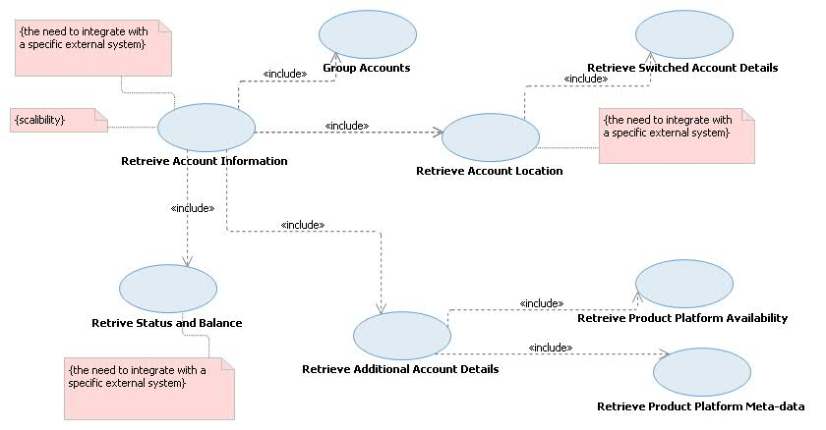

### Apply Account Posting

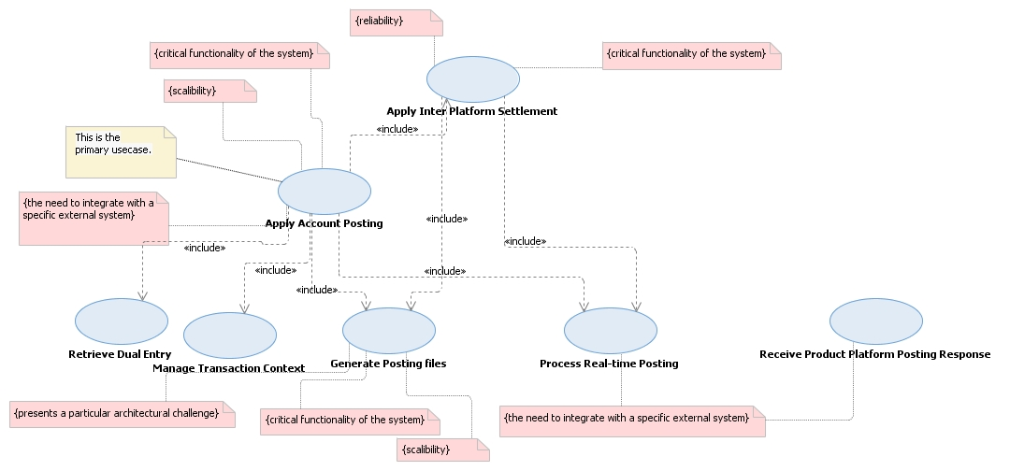

## Functional Requirements

The functional requirements related to this Architecture Description can be found in this section:

Accounting Hub will be delivering the following functions as part of this release:

1. Account enquiry for accounts on hHBOS product platforms (limited to identifying the product platform for the account)
2. Availability information for the hHBOS product platforms *(No requirement identified)*
3. Account Posting to hHBOS product platforms
4. Account Posting features:
   1. Generate Posting files for the product platforms reusing the file generation capability within Transaction Bus
   2. Aggregate Posting entries before sending to product platforms. Including postings to HOCA Accounts
   3. Process unprocessed messages held in failed nodes.
   4. Generate inter-system accounting to settle between product platforms
   5. Generate multiple transaction groups based on a single posting request, and manage transactions across different groups
   6. Process incoming posting files and generating posting entries for product platforms. (Not covered as part of this AD). *Please note: This requirement is mentioned for traceability*

### Account Enquiry

The following usecase diagram shows the top level usecases to be delivered to support query facility for HBOS postings.

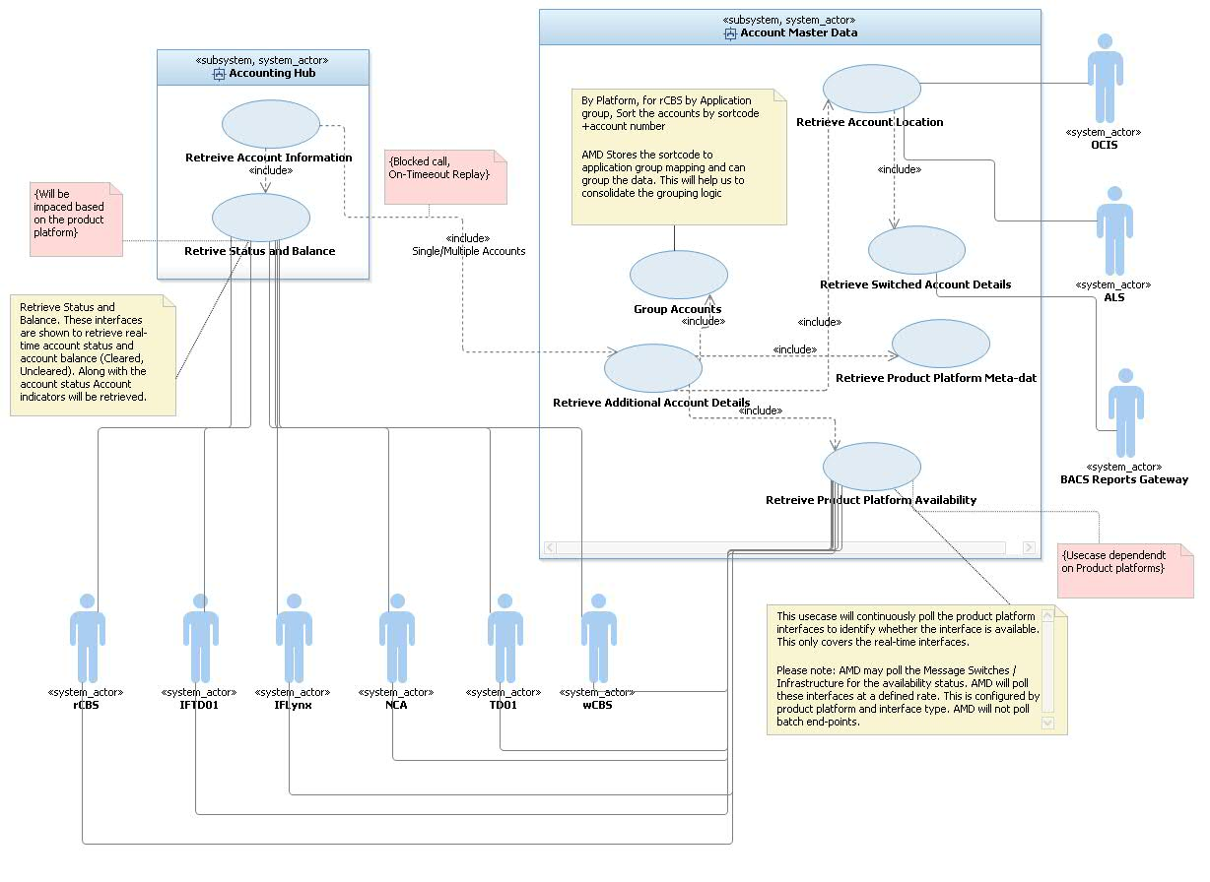

Key points:

1. Account Master Data (AMD) to will be responsible to resolve the product platform for all accounts in the request. Accounting Hub will invoke this service to identify the static data for the account. The benefits/justification is as follows
   1. This approach simplifies the orchestration from Accounting Hub services to invoke OCIS and ALS service.
   2. Account Master Data (AMD) will not cache the calls to OCIS and ALS thus there will be no reduction of traffic to these platforms. (The P&C team will have to be involved to verify the capacity requirements). The project volume for hHBOS is quite low.
   3. AMD to invoke BACS report Gateway to identify whether an account is switched out. The switched out account details will not be used by Accounting Hub for any processing. It will use the sortcode+account number sent as part of the incoming message.
   4. AMD to identify the HOCA account number for any incoming posting request
2. Accounting Hub services to connect to the hHBOS platforms to retrieve status and Balance. This interface will re-use any existing api/service on the hHBOS product platforms. *Accounting Hub is connected to rCBS, this interface is delivered as part of TMH Release 4.* *(However there is no requirement from the Payment workstream projects to deliver the functionality. In future if there is a need to deliver the status, balance and indicators Accounting Hub will have to extend the current design and add the interfaces to the hHBOS product platforms. These interfaces when required will have to be change requested in the project)*
3. Account Master Data will have interfaces to the hHBOS platforms to identify whether the platform is available (Planned/unplanned outages). Accounting hub will use the availability information before forwarding any request to the product platform. AMD will build this for rCBS but the interfaces with the hHBOS product platforms will be kept under hold till a payment project requires this feature. The design for this functionality is already defined in the previous AD (Release 1 and Release 2 AD)

Below are the links to the previous AD.

<http://teamspace.intranet.group/sites/ITDesRep/IT%20Design%20Repository/E2E024%20-%20Accounting%20Hub%20Phase%201%20and%202-Part%201.zip>

<http://teamspace.intranet.group/sites/ITDesRep/IT%20Design%20Repository/E2E024%20-%20Accounting%20Hub%20Phase%201%20and%202-Part%202.zip>

Please Note: The volumes for CHAPS and international are very low hence there is no need to build this in-scope for the current project. In future if the payment projects require this functionality for a hHBOS product platform the design will be extended, re-using the same patterns

1. All the usecases shown above (except AMD::Retrieve Product Platform Availability, and Accounting Hub::Retrieve Status and Balance) will be product platform agnostic. This means these use cases will not be impacted if any new product platform is added. The two usecases mentioned AMD::Retrieve Product Platform Availability, and Accounting Hub::Retrieve Status and Balance will have externalised rules for transformations, validation, and routing. Configuration data will be maintained for these interfaces to the product platforms.
2. Account Master Data will have to load the HOCA accounts file for Corporate, Commercial, Mortgage customers. ($) These HOCA accounts will be maintained within AMD. AMD will not be the master source of this data and hence will have no online maintenance features for this data. As part of the Additional Account Information the HOCA account details will be sent to Accounting Hub. Considering requirement for Unisys Mortgages the HOCA account number reference data is static information. Hence that will be loaded as an initial upload. If any changes are needed in the data a CR will be raised by the changing project on Accounting Hub, and the database inserts will be performed. For HOCA this project does not have any requirements to extend the existing batch file processing. If needed (*) AMD has a batch interface which it uses to load the rCBS NPA data file. The same approach will be used to build the data load solution for the HOCA data till the file solution is designed and built.

*(Please Note:*

1. *($) The actual file requirements will have to be provided by the Payment workstream projects).* The file upload requirements will be reviewed along with the Payment workstream projects, in order to build the upload solution.
2. *(*) The large file solution is being designed in parallel, and once the solution is built the same will be used for Payment, Posting and Reference data files)*

The following diagram shows the logical orchestration for the Retrieve Additional Account details on AMD.

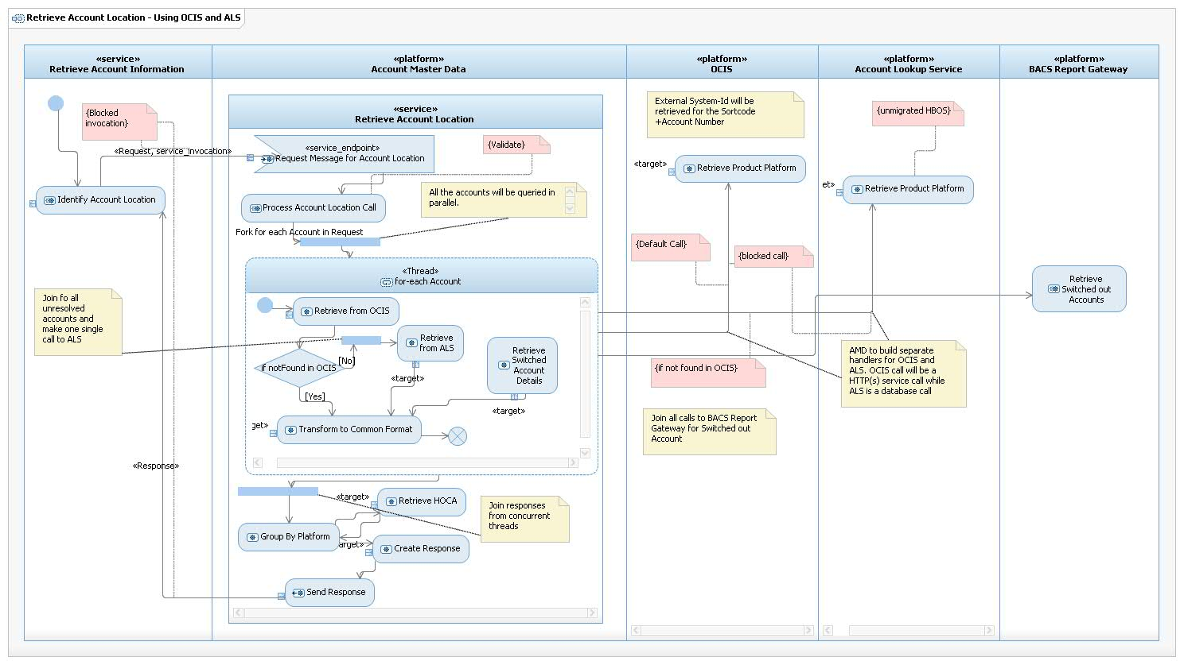

The following diagram shows the logical orchestration for the Retrieve Platform Availability on AMD.

If a payment stream wants Accounting Hub to hold the postings in stand-in while the product platform is deemed unavailable. AMD needs to provide the availability information for these product platforms. AMD will connect to rCBS, wCBS, NCA, TD01, IF-Midtier to identify their availability (availability for hHBOS platforms are out of scope for this project). The route will be exactly same as a posting message would take from Accounting Hub to the product platform. For example wCBS by a message switch and if either the message switch or wCBS is unavailable the Posting would not reach wCBS hence this interface would route the availability enquiry through all the hops in-order to establish end-to-end availability. IF platforms will be considered unavailable if IF-Midtier does not respond within a defined window. For this implementation the assumption is not to do stand-in for the hHBOS product platforms hence the consuming platform for Account Posting service will not set the stand-in flag. If the flag is set then Accounting Hub will ignore the value of the flag.

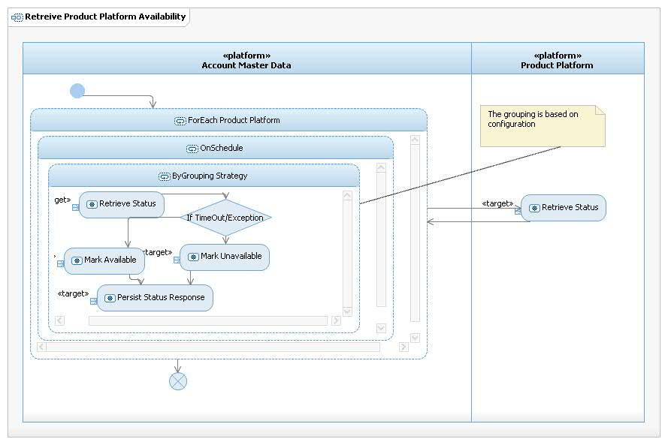

The above functionality would be delivered based on requirements from the consuming projects. AMD will have to build additional interfaces to deliver the availability service. If these interfaces do not exist within the product platforms then the availability information will be based on the static reference data stored within AMD for the platform.

As part of this project AMD must deliver the availability service to rCBS. The design for this service is already approved as per (AD link)

<http://teamspace.intranet.group/sites/ITDesRep/IT%20Design%20Repository/E2E024%20-%20Accounting%20Hub%20Phase%201%20and%202-Part%201.zip>

<http://teamspace.intranet.group/sites/ITDesRep/IT%20Design%20Repository/E2E024%20-%20Accounting%20Hub%20Phase%201%20and%202-Part%202.zip>

During periods of unavailability for rCBS Accounting Hub will hold rCBS postings in stand-in. As part of this project this approach will be taken for NPA postings to rCBS based on the original principal postings to the hHBOS customers. *For example: Based on the Accounting model shared the inter-platform settlement account will be in rCBS. Accounting Hub would first post to wCBS and then it would try to post to rCBS. In case rCBS is unavailable Accounting Hub will store the postings in standin. The decision whether to store the non-customer postings will be controlled through the stand-in flag configured in AMD for the scenario.*

Please Note:

1. The stand-in flag for non-customer posting entries will be configured in AMD in the Scenario to Req-Response mapping
2. Payment projects will drive the need to build the Product Platform availability service

### Account Posting

The following diagram shows the participating use cases required to deliver the account posting service to the hHBOS product platforms. The Account Posting service is being delivered as part of TMH release 4 for TBT SOC. The current Account Posting service posts to rCBS only. The limitations of the current implementation are:

1. The service can post to only one platform as part of a single posting transaction. This covers for principal, contra and settlement entries destined for a single platform.
2. The functioning of the service is dependent on the underlying API on the product platform. For example the current rCBS API only allows for the principal Cr/Dr and the corresponding contra. Hence multiple entries for a transaction will have to be sent separately. The current implementation does not allow to orchestrate between different legs of the same transaction.
3. The current service is for online postings only. It cannot generate a posting file.
4. Creating of aggregated entries for HOCA postings from individual posting transactions to be implemented. The same can be used for Contra postings. AMD will store this aggregation attribute as part of its NPA reference data.

The above features are required to implement the posting use cases for hHBOS platforms.

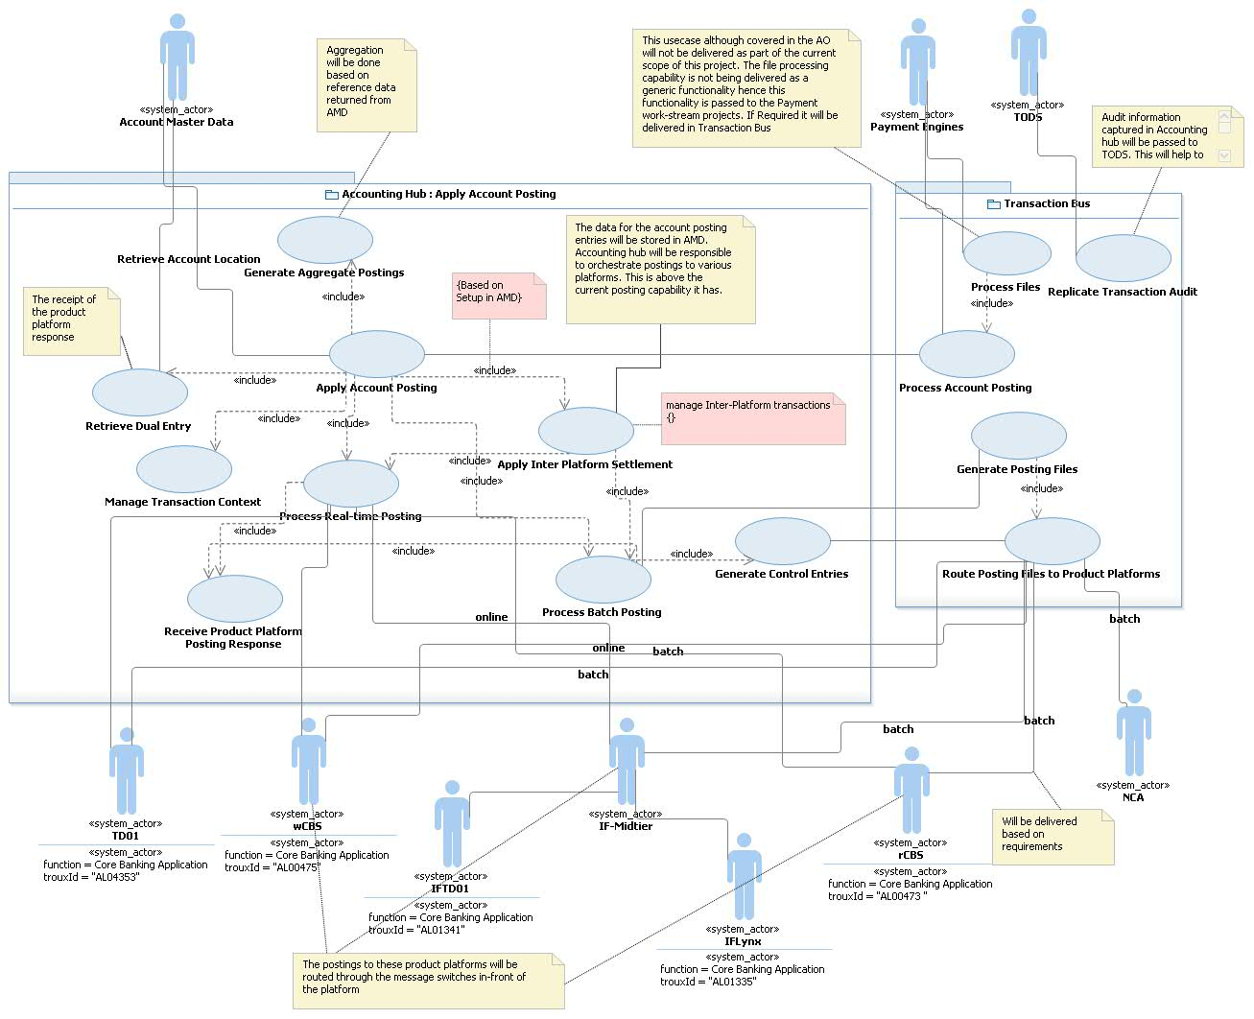

Key points:

1. Accounting Hub will be responsible to resolve the Product Platforms before it sends the postings to the product platforms. Accounting Hub does not decide whether the posting needs to be forwarded, it forwards the posting to the product Platform. If the Posting is rejected by the Product Platform as the account is blocked for payments the response from the product platform will be returned back to the consumer to the Account Positing Service.
2. As per the scope of this project the Transaction Bus will be the only consumer to the Accounting Hub::Account Posting Service. Payment engines like LCS will pass the Account Posting requests through Transaction bus to Accounting Hub.
3. If the consumer (LCS🡪Transaction Bus) indicates stand-in in the incoming posting message to Accounting Hub, Accounting hub will provide stand-in capability for customer credit postings. *(The design for stand-in is detailed in the Accounting Hub AD. Refer References below)*
4. Accounting hub will get all the posting entries by scenario from AMD::GetNPADetails. The data will be configured in getNPA by scenario. getNPA to provide the following:
   1. Posting entries by Product Platform
   2. Sequence of entries to be passed to a product platform
   3. Posting Mode (online/batch including schedule) and whether the posting is via MQ or a posting file will be generated
   4. Posting Type (Single/Aggregated)
   5. If a transaction involves multiple steps then this service will also send the compensation entries.

These would be added to the current service response. The current service response includes the NPA’s required to send the contra postings getNPA service will group all the entries by “Global Posting Sequence”, Product Platform and Posting Sequence. The sequence would be a combination of two sequences “Global Posting Sequence” and Posting Sequence to a Product Platform. Based on Global Posting Sequence Accounting Hub will make parallel / sequential calls to the product platforms. If a posting fails then Accounting hub will send the compensating entries to the product platforms.

The postings to different product platforms can be both online and batch as part of the single transaction. Accounting hub will maintain the transaction coordination context across all the postings for a incoming posting transaction.

*(Please Note: even if the posting is sequential but threads must never be blocked)*

1. Accounting hub to manage inter-system account posting. *For example if the current FPS model is followed then Accounting Hub will have to post the customer postings to the product platforms while it passes the settlement contra (aggregated) to rCBS. Accounting hub will manage the transaction context across these posting entries. Accounting hub will also generate the necessary compensating entries an exception (business/technical) is raised.*
2. Accounting hub will send both MQ SOAP, MQ non-SOAP messages to the product platforms to pass the posting entries to the platforms. Posting files will be generated by Transaction Bus using the bulking capability and sent to the product platforms as files.
3. For postings which are file based Accounting hub will send individual entries to Transaction Bus. Transaction bus will collect these entries till either the file posting schedule reached or Transaction Bus receives a control message from Accounting Hub (aka Generate Control Entries). Accounting Hub would consolidate the entries and generate the control entries by file, product platform and application groups wherever applicable. Only rCBS has application groups and rCBS is used to post the inter platform settlement entries. The assumption is the posting to rCBS will be online however this is dependent on the accounting model for hHBOS accounts and by scenarios.

*Please note: This approach can be followed for posting to CAP e.g if the SDEP files are routed through Transaction Bus 🡪 Accounting Hub, rCBS entries will be posted online and the CAP file will be generated through the process of Accounting Hub to Transaction bus to CAP. The incoming SDEP file processing is outside the scope of this project and will be covered under the relevant payment workstream project.*

1. Apply Account posting will have a sub-usecase “Manage Transaction Context” added to the current implementation to manage the transaction context across the different posting entries. As mentioned in above this usecase will maintain transactions across online postings and batch postings.
2. Account Posting Response. This usecase is delivered as part of TMH release 4, however the posting is limited to online postings. As part of this release this usecase will be extended to handle file entries as well. Transaction bus will send the file response which will be captured and fed to the components delivering “Manage Transaction context” usecase. This usecase is separated out to handle different types of responses including format, mode and message exchange patterns
3. Accounting hub will maintain the posting entries by scenario and based on the reference data it will post to various platforms. The system will perform based on the reference data and the sequence of execution. This will protect the projects from any change to the accounting models or NPA’s migrating from NCA to rCBS.
4. The scope for posting is for all payment schemes (including IAT) and all account transactions (e.g. charges). Any posting scenario can be accommodated without any programming changes. The data in AMD is what needs to be configured for any new scenario.
5. For posting to Corporate / Commercial customers requiring aggregated/single postings, to HOCA accounts Accounting Hub will post to the collection accounts either as single individual postings or as aggregate. Aggregate postings will have an associated schedule. If the postings are to be sent as files then Accounting Hub will send a consolidated message for all aggregated postings to Transaction Bus🡪TODS and files will be generated. Online posting will be done by Accounting Hub. For example HOCA accounts postings for Unisys Mortgages postings.

*Please note: For file aggregate postings there is no requirement from the Payment stream projects hence this functionality should be delivered when a consumer is identified for this requirement.*

1. The actual data for posting and the compensating entries will be delivered by the Payment engine projects. The entries will be data configured in Account Master Data. The logic to interpret and pass the entries to the platforms will be delivered as part of this project.
2. Audit information for Bulk files will be sent to TODS from Transaction Bus. This must include the audit data for files which Transaction Bus is bulking on-behalf of Accounting Hub. This data replication to TODS must use the pub-sub pattern delivered for TBT SOC by TODS.

The logical orchestration within accounting hub to generate transactions based on response from getNPA. The additional functions implemented over Release 4 will be getNPA can send multiple entries. These entries will be grouped based on the posting order. The end-to-end state model will be distributed across nodes. These posting groups can be sent and received from and to in different nodes. A common repository will be used to manage the state for the entire transaction.

Please note: Similar distribution and orchestration pattern is delivered by Accounting hub as part of multiple account enquiry for TBT SOC. However there is a difference between the inherent nature of the message. In this context it is a posting response and Accounting hub will have to have a deterministic response across different posting scenarios, while in the current implementation the response is non-deterministic. Hence this implementation will have to have definite error responses generated to the consumers and compensation entries generated for the product platforms for entries which have been successful as part of the transaction context.

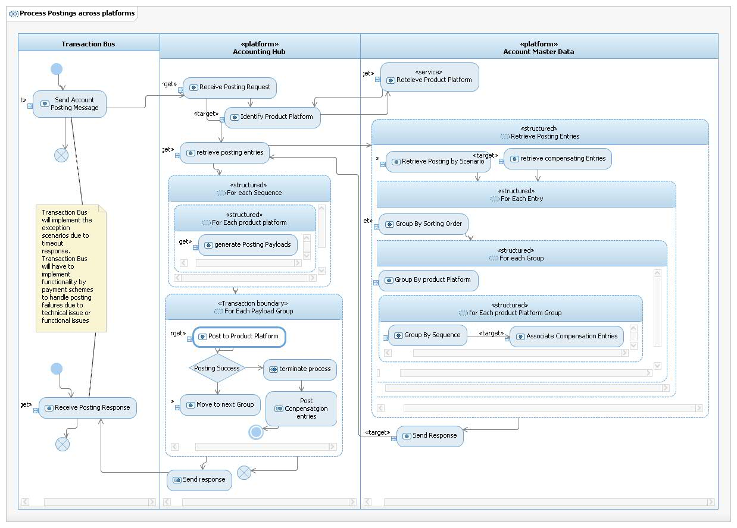

Key steps:

1. Group based on Account Model Sequence / Product Platform / Sequence for Postings
2. Post the entries in the order specified in the above step
3. Make parallel calls based on the sequence defined in step 1
4. If a step fails terminate the process and generate compensating entries
5. If a compensating entry failed then generate alerts.
6. If the posting mode is file then the message needs to be sent to the Transaction bus to generate the file for sending to the product platform
7. If contra entries needs to be generated for a file, accounting hub to generate control messages to transaction bus.

Each step must have a audit for compensation. Additionally the node which is processing fails then one of the available nodes will pick the message and continue the process.

The entire process will be managed within one distributed transaction context. This will ensure rollbacks are handled gracefully.

If a posting is to be done as files then the message will be sent to the Transaction bus. Transaction Bus will bulk the entries by file types. Either based on the schedule or the control message from Accounting hub the files will be physically generated by the Transaction bus and sent to the product platforms. As a pattern there is no response for a posting file to the product platforms. Hence Transaction bus will generate a response for Accounting Hub. Accounting Hub will use this response and proceed with the transaction.

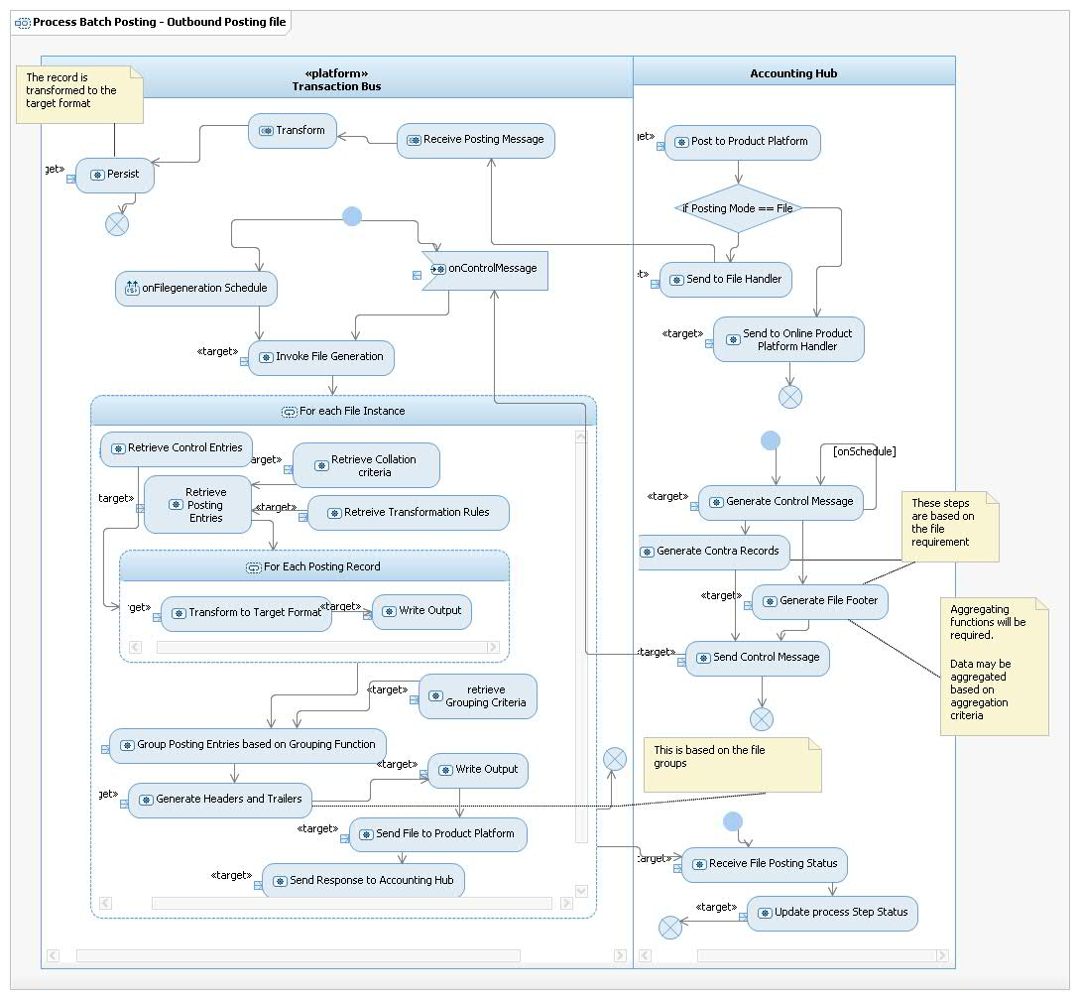

Accounting Hub will maintain a batch reference identifier. It would send this identifier to individual postings to Transaction Bus, which needs to be bulked in files. The same batch reference identifier will be resend by Accounting Hub as part of the control message to Transaction Bus. Transaction bus will use the Batch identifier to retrieve the posting entries to be grouped in the file. At one point there can be multiple batches active. Each batch will have a different batch Identifier. A batch will be related to only one file. There can be multiple files for the hHBOS platform and for all platforms. Accounting hub will maintain a lock-based batch identifier generation algorithm in order to generate the batch identifiers, this would allow Accounting Hub to control the generation of batch identifiers and ensure the same identifiers are not reused in different batches.

Transaction Bus after it generates a file will send a response to Accounting Hub with the posting identifiers. This message would be consumed by Accounting Hub and will be used to complete the status of the in-flight batches.

Accounting Hub will treat Transaction Bus as replacement for the offline Product platforms. It would send the Posting entries which needs to be bulked in files. Transaction Bus will send an accept response. Based on the response Accounting hub will complete the posting process and respond to the account posting consumer.

Please Note: The current solution on the hHBOS product platforms does not send a posting response to the engines for posting entries sent in file. The unapplied postings are handled with in the product platforms for postings sent in file. This project will continue to use the current BAU process.

If Transaction Bus receives Header and/or Footer, and provided there are aggregated fields are present for example number of records / total value of payments then Transaction Bus will verify the value of these fields. Transaction Bus needs to have aggregation functions to support this requirement. (Please note: The file structures are being analysed by the BA’s this feature may not be required for CHAPS and International Project. If not required this feature will not be delivered)

Data may have to be grouped based on criteria. The grouping criteria will be configured for each file type. Posting entries and Contra entries may have to be grouped together. This is based on any requirements given by the Payment Stream projects and the file structures for hHBOS product platforms. (Please note: The file structures are being analysed by the BA’s this feature may not be required for CHAPS and International Project. If not required this feature will not be delivered)

Manage Transactions Across product Platforms: The following diagram is a logical orchestration within Accounting hub to manage transactions across multiple transactions to different product platforms.

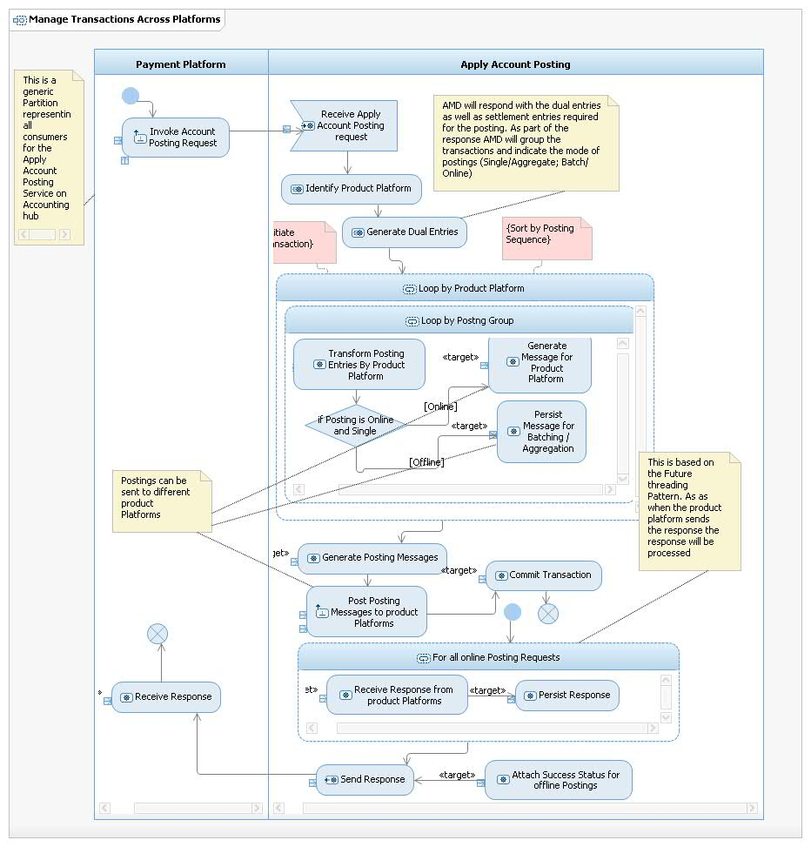

The following diagram is a logical orchestration of the Aggregation Posting flow:

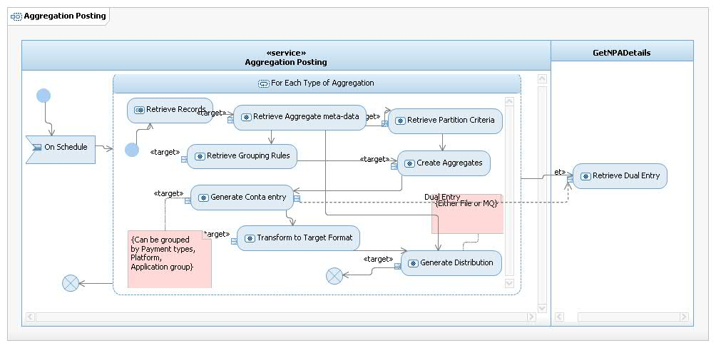

Generate Distribution is a generic activity step. This step will be used to send the postings to the product platforms:

1. Either directly from Accounting hub if the distribution mode is online,
2. Or through transaction bus if the distribution mode is file

In both the above cases the output format will vary by product platform and by type. The requirement for Aggregated posting will have to be provided by the Payment engine workstreams. These workstreams will have to provide the file or message format.

The current Accounting Hub design does not cover for posting messages sent to one Accounting hub Instance. Accounting hub instance has started processing the message and has gone down before sending to the product platform. Once the message is sent to a product platform it can be processed by other available instances. The return flow is simple compared to the request flow as in the response flow the Product Platform message is only transformed and sent back to the consumer.

This scenario although may have a very low probability of happening but is a valid scenario. In order to cover this scenario Accounting Hub will implement a new flow to monitor the transactions stuck and not progressed. Accounting hub will have to audit messages as soon as it reads it from queue. This process will read the audit table for any state changes for that message. If the state change does not happen

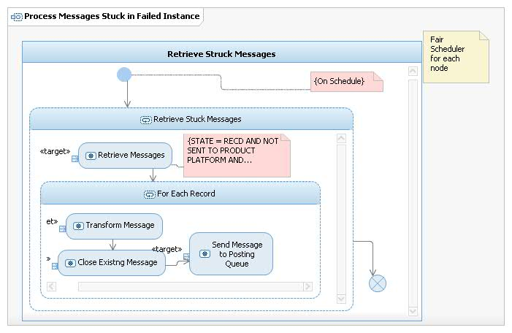

### Generate Batch Posting Files

This is an extension to the file generation capability in Transaction Bus. Accounting Hub will use this feature to generate posting files and sending these files to the product platforms.

These files can be of any format. The format is explained in the interface specification documents. The posting file generation is a separate component delivered within this project scope. To mitigate delivery risk this functionality has been divided into two separate solution options (1) large file (2) small files. As per the scope of this project the small file processing solution will be delivered.

This component will bulk the posting records generated by Accounting Hub. The file generation to product platforms will be triggered either based on a defined schedule or a control message from Accounting Hub.

The solution is kept generic in-order for future reuse of generating small posting files in future. If the file does have a footer / aggregated contra entry then Accounting Hub will generate the required data and send to Transaction Bus. Transaction Bus will transform and group based on criteria and post to the product platforms.

As per the current scope of this project this feature will be used to generate the International files for wCBS, TD01, IF and NCA. This same feature will also be used to generate CHAPS files for NCA

|  |  |  |  |
| --- | --- | --- | --- |
| Product Platform | Scheme | File Format | Header/Footer Required |
| wCBS | International | AK350 | Yes |
| TD01 | International | Proprietary | Yes |
| NCA | International | URBBT01 | Yes |
| IF | International | Proprietary | Yes |
| NCA | CHAPS | CHPBI01 | Yes |

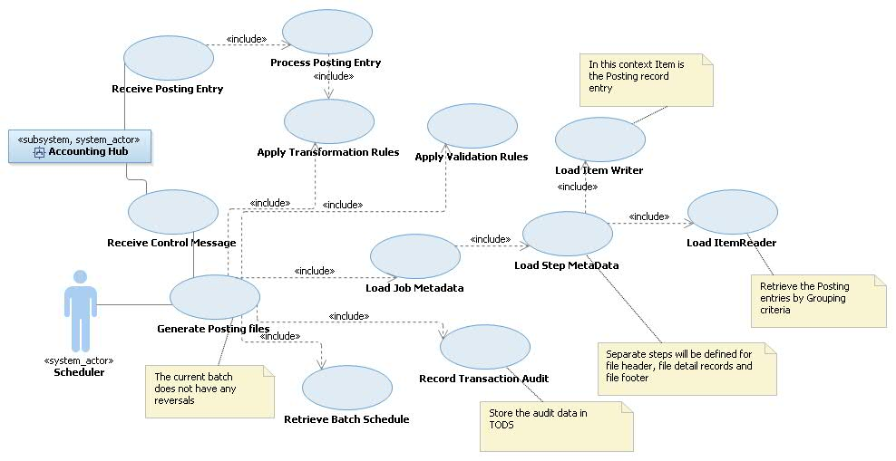

### Manage Posting Reference Data

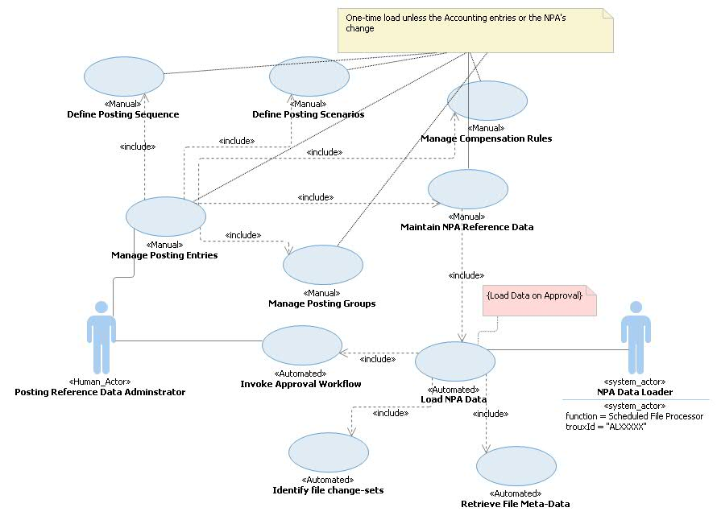

*The stereotypes on the usecases identify whether they are manually or executed through the application. The key system usecase is the reference data loader. This is a batch component and will be used to load the reference data files.*

The usecases defined above are key usecases to be delivered by Account Master data as data-services. The current data service “getNPADetails” will be extended to provide the following information as part of the single call:

1. Posting entries by Payment scenarios
2. Posting mode (file, online) for each of the entries
3. Posting type (single/end-day aggregated/ time-bound aggregation) for each of the entries
4. Entries to be grouped by Product Platform and posting sequence
5. Compensation entries if a posting fails
6. Collection account details/ HOCA Account Number – This will be required if the posting is required to be done to the HOCA account number instead of the incoming Customer Account number.

The data needs to be validated before the data is loaded. There needs to be a human approval if any major changes are introduced in the data. Reference data will be stored to indicate the possible number of changes. If the number of changes goes beyond the acceptable threshold the data must be approved before loaded.

Data will be cached (in an external data-cache) and the cache refreshed after the data is loaded/refreshed. All queries must first hit the cache, in case of cache miss the query must reach the database.

Please Note: All reference data within AMD including getNPA will be cached. OCIS, ALS and Switched out and renumbered account details will not be cached.

For Unisys mortgage postings: AMD must respond with the HOCA account number. The Account Posting request will contain the customer sort code and account number. AMD needs to store the HOCA Accounts as part of its reference data. This would be first queried and as part of the data setup the transformation flag will be stored. If the transformation flag is set then the customer account will be replaced with the HOCA account number before replying to Accounting Hub. If the account is renumbered, the product platform would be identified for the renumbered account. i.e Accounting Hub would use the renumbered account details in-place of the original customer sort code+account number. Accounting hub will send the posting to the HOCA account number as sent by AMD. Both these elements would be set in the response message to Accounting Hub.

## Non-Functional Requirements

All the Non-Functional Requirements related to this Architecture Description can be found in this section:

Please note the volumes mentioned in this section may be refined after the Payment workstreams provide more detailed requirements.

The following additional volumes of transactions to be supported for hHBOS:

|  |  |  |  |
| --- | --- | --- | --- |
| Payment Scheme | Account enquiry (day) | Account Posting (day) | Time window |
| International | 800 | 800 | Chaps processing window (5:30AM to 4:30PM) |
| CHAPS | 50 | 50 | International processing window(6AM to 7PM) |
| Clearings | 100,000 | 100,000 | Batch to be posted after midnight |

Please note: Clearings project will use Accounting Hub services however the requirement for Clearings is not covered in this AD.

The following are the volumes which would need to go to rCBS

|  |  |  |  |
| --- | --- | --- | --- |
| Payment Scheme | Account enquiry (day) | Account Posting (day) | Time window |
| International | 50000 (already covered by ePayments) | 50000 | Chaps processing window (5:30AM to 4:30PM) |
| CHAPS | 60000 | 60000 | International processing window(6AM to 7PM) |

## Requirements Traceability

The following diagram shows the traceability for Account Enquiry

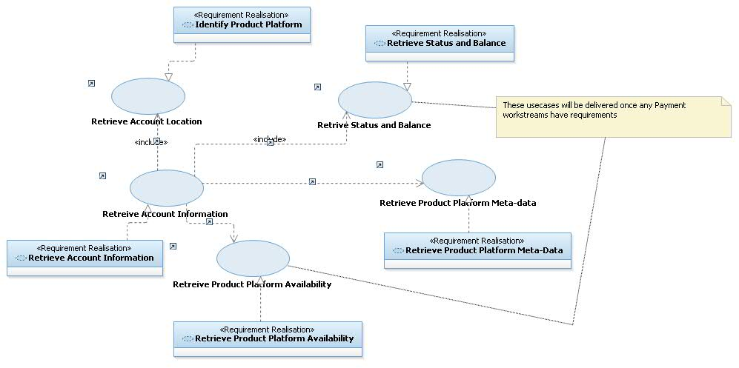

The following diagram shows the traceability for Account Posting

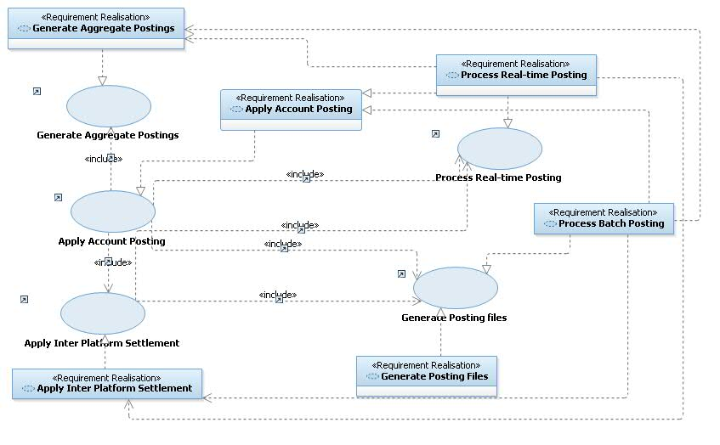

## Business Impact Assessment (BIA)

Accounting Hub BIA can be found in the following link. The scope for this project does not need a separate BIA hence this project will continue with the existing BIA for Accounting Hub.

The Payment projects will perform their specific BIA

. <http://teamspace.intranet.group/sites/DOT/BIAs/MLS3404_TMHAccountingHub_2013.xls>

A separate BIA must be reviewed or created for every application impacted by the solution. BIAs are completed by the business data owner for a business system. N.B. applications may be part of more than one business system, therefore multiple BIAs may be impacted by a solution.

Complete the table by including the Application Name(s) and Application Troux ID(s) that align to each BIA, the BIA ratings and a description of how this design meets the various BIA requirements e.g. how the choice of host platform is driven by the BIA classification as directed within the Infrastructure Hosting Decision Tree standard (published in the EA Reference Library), how an application is architected to run as multiple active-active components.

Note that when making reference to using the Infrastructure Hosting Decision Tree, it is important to state how the selected option meets the resiliency requirements, not just which platforms have been selected.

Confidentiality and integrity ratings are defined as: Critical, Major, Medium, Low and Minor

Availability ratings are defined as: High, Medium, Low and Non-Critical

# application view

The following legend is used to identify changed applications



## Outline Application View

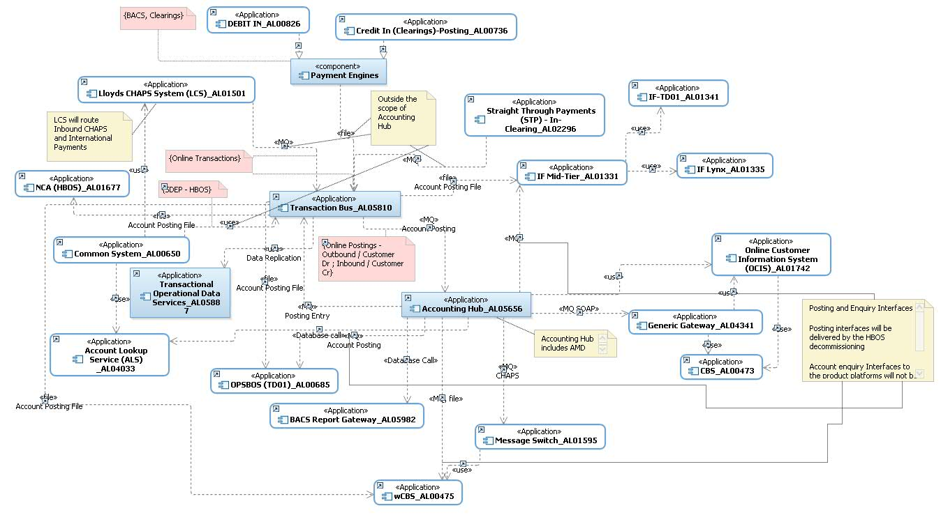

The diagram above is a logical diagram showing the interfaces from Accounting hub. Account Master data is considered to be part of accounting hub.

Accounting hub can be split within two major applications. (1) Accounting Hub Services and (2) Account Master data

Accounting Hub services – provide two capabilities account enquiry and account posting. The posting is split as on-line and batch. For online it will primarily be an MQ message (SOAP/non-SOAP), for batch Accounting hub will generate posting files for the product platforms leveraging Transaction Bus file generation functionality.

Accounting hub will leverage the a File processing module in Transaction Bus. Accounting hub Services will mark the delivery mode as file. The file processing module within Transaction Bus will generate the posting file for the platform. This section describes the architecturally significant parts of the design model, such as its decomposition into subsystems and mapping to applications and services. It also provides a way of validating that no significant subsystems have been missed by illustrating a static test of the **key** Use Cases in Sequence Diagrams.

If there have been changes since the Architecture Overview was finalised then update this section accordingly. Otherwise, mark as No Change.

Refer to the Outline Application Architecture instructions in the Usage Model for Application Architecture in RSA (which is available on Compass). Insert the relevant diagram into this section. See Hint and Tip RSA Diagrams – Copying or Saving.

## Detail Application View

### Account Enquiry

The following diagram shows the Account Enquiry service. Key Points

1. Account Lookup Service will resolve the hHBOS product platform. Based on configuration Accounting hub will forward the enquiry request to these product platforms.
2. Interfaces will be built from Accounting Hub to the hHBOS product platforms. These interfaces will be MQ/HTTP interfaces. This will have to be completed after the interface definition is complete.
3. AMD will cache all reference data, this will reduce load on the databases.

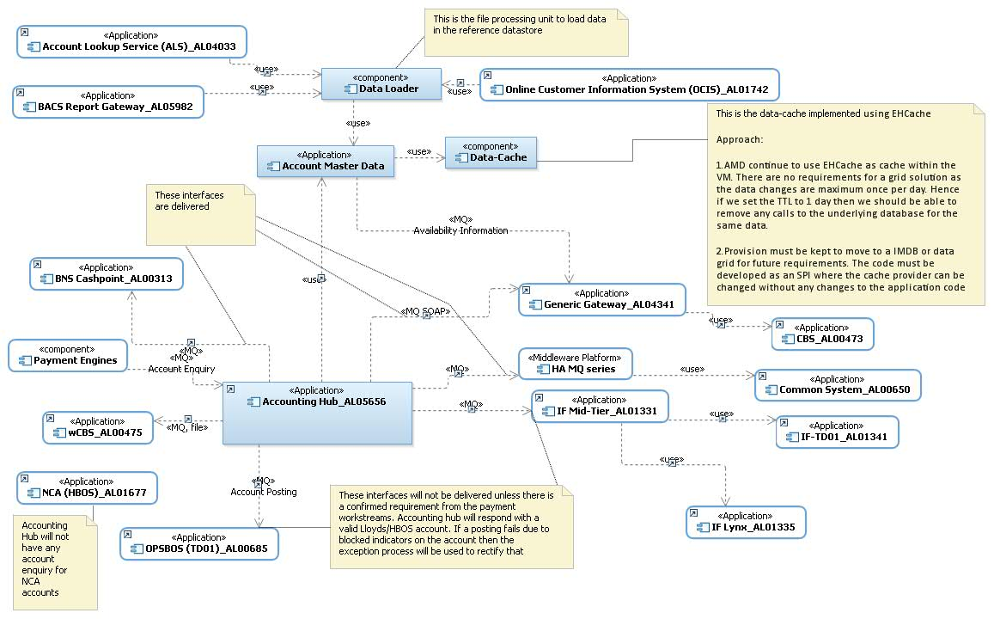

| No | Name | Interface from | Interface to | Protocol/ Transport | Message format | Interface available | Connected with Accounting hub |
| --- | --- | --- | --- | --- | --- | --- | --- |
|  | Additional Account Information | Accounting Hub | Account Master Data | HTTPS | SOAP | Yes   1. Changes will be done to the service contract. 2. AMD will provide all the product platform identifiers including rCBS/CAP/Common System | Yes |
|  | getNPADetails/ getDualEntry | Accounting Hub | Account Master Data | HTTPS | SOAP | Yes   1. Changes will be done to the service contract. | Yes |
|  | F929/ OCIS API for Account Details | Account Master Data | OCIS | HTTP | SOAP | Yes | Yes. Currently the api is directly invoked from Accounting hub Broker flows. The change is to invoke this api from AMD instead. |
|  | Data Cache  (This is a technology interface to make the query responses faster) | Account Master Data | Data Cache (EHCache) | Native /Java call | Java Data objects | This component exists in the bank and within AMD. However Account master data need populate the data in the cache. Additionally for each enquiry it needs to investigate the cache an on cache-miss forward the query to the database. | Yes |
|  | Account Enquiry 🡪 rCBS | Accounting hub | Generic Gateway 🡪 rCBS | MQ | SOAP | Yes | Yes (Already delivered as part of TMH 4) |
|  | Account Enquiry 🡪 Common System | Accounting hub | HA Gateway 🡪 Common System | MQ | XML | Yes | Yes (Already delivered as part of TMH 4) |
|  | Account Enquiry 🡪 BNS Cashpoint | Accounting hub | Generic Gateway🡪BNS Cash point | MQ | SOAP | No (Currently being delivered for TMH 5.1) | No (Currently being delivered for TMH 5.1) |
|  | Account Enquiry 🡪 IFTD01 | Accounting hub | IFTD01 | Interface to be identified |  | No | No  There is no requirement for Balance and real-time status for IF accounts |
|  | Account Enquiry 🡪 IFLynx | Accounting hub | IFLynx | Interface to be identified |  | No | No  There is no requirement for Balance and real-time status for IF accounts |
|  | Account Enquiry 🡪 TD01 | Accounting hub | TD01 | Interface to be identified |  | No | No  There is no requirement for Balance and real-time status for IF accounts |
|  | Account Enquiry 🡪 wCBS | Accounting hub | Message Switch 🡪 wCBS | Interface to be identified |  | Yes | No  There is no requirement for Balance and real-time status for IF accounts |
|  | Account Enquiry 🡪 NCA | Accounting hub | NCA | Interface to be identified |  | No | No  There is no requirement for Balance and real-time status for IF accounts |

The following is the component diagram for Account Master Data services.

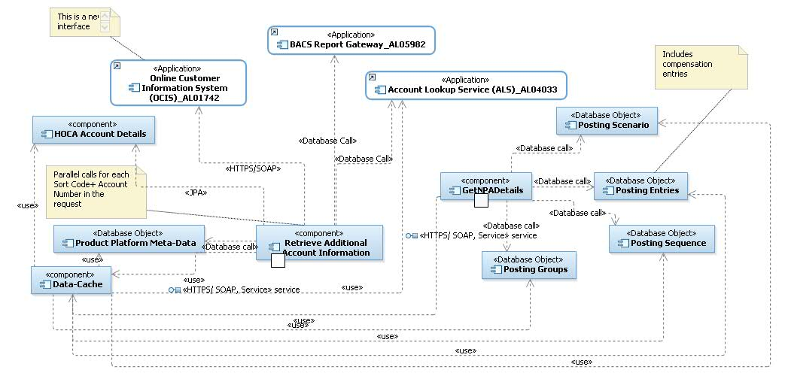

As shown in the above diagram all data elements in AMD will be cached. The two services will first query the cache. This data cache will be refreshed based on the cache-eviction policy. Apart from sortcode+account number details (Not from OCIS. ALS and RLS) every other data element will be evicted when the data is refreshed. For sort code + account number (Not from OCIS. ALS and RLS/ i.e non-customer) cached will be evicted this eviction policy will be controlled within the application. (details of the eviction policy will be covered in the ADM documents)

### Account Posting Flow

The following diagram shows the top level Accounting Hub Posting Components. Accounting Hub till Release TMH 4 only supports online postings to rCBS for CHAPS. As part of HBOS Decommission Accounting Hub will have to post the posting transactions as files and online to the hHBOS product platforms for all payment schemes and all transaction types. In order to do so Accounting Hub will use the Transaction Bus to generate and send the files to the product platforms.

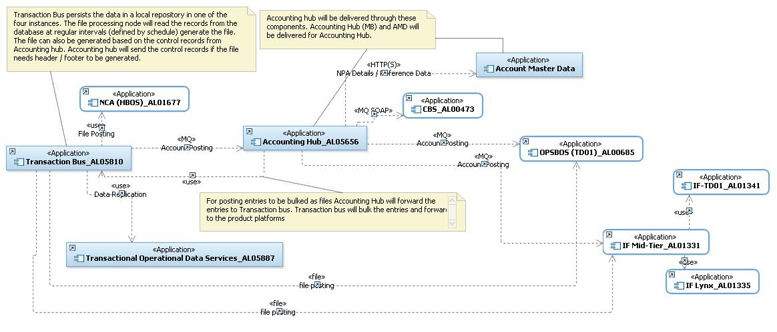

The file processing as delivered as part of this project is a low volume file solution. This will leverage the File bulking feature of Transaction Bus. This function will be delivered on all the instances of FTM. Currently Transaction bus is delivered on 4 FTM nodes. However the solution is based on node affinity i.e the first node which receives the message for a file will be the node where the file will be generated. This limitation is because each node has a database attached to it and it will use the database instance to persist the posting entries. During file generation it will retrieve the entries from the same database instance. This introduces a need to send the message to be bulked in a particular file from Accounting Hub to a defined node. This approach makes both the applications highly cohesive(*). The other alternate is to create a redirection flow which would redirect the message from Accounting Hub to the right FTM node. Accounting hub as part of hHBOS decommissioning will use these FTM instances to generate posting files for the hHBOS product platforms.

*Please Note: (*) The reason this option is cohesive is Accounting Hub will be impacted if any changes happen to the Transaction bus processing node. Before sending the posting Accounting Hub would have to know whether the Transaction Bus Node processing the relevant file type the message is for is available. For example if DR is invoked and the node is replaced by a DR node Accounting Hub will have to change to redirect entries to DR. Hence this is not a preferred approach.*

The Accounting Hub message broker component (AL05656) will pass entries to the file processing unit that needs to be sent to the Product platform as batch posting. During processing of an incoming Posting request if a set of posting entries needs to be sent to a product platform as a file then the message will be generated and sent to Transaction Bus. The file generation function will bulk the entries and send it to the product platform. Transaction Bus will send the posting response back to Accounting Hub. Transaction bus will not receive any posting response from the product platforms. This means if a posting could not be applied due to blocked indicators on the account then the exception processing will continue the current process.

Posting entries can be a combination of both online and file. Accounting hub will continue to manage the online entries while the file generation will be delivered by the Transaction Bus. Accounting hub process is node agnostic. It uses a single database instance to maintain state across different nodes. This also makes the system more resilient as it can handle node failures.

### Account Posting

The following diagram shows the high level component to process the Posting entries. This contains both the file and online transactions

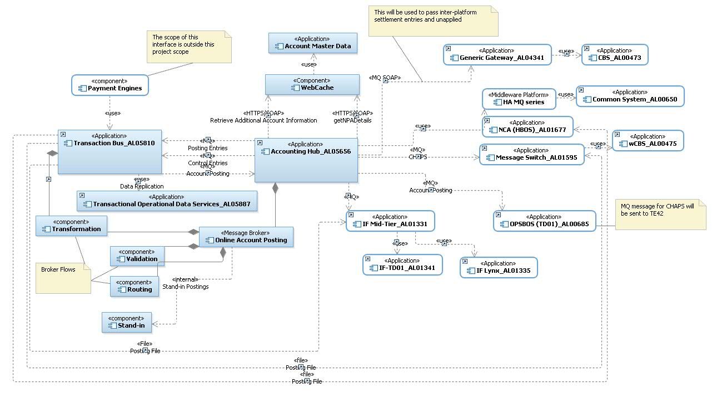

Key changes:

1. Transformation, routing and validation are pluggable components. These will be different for each interface
2. File processing component will be delivered by the Transaction Bus. Different Jobs and Tasks will be created for each file interface (Outbound only)
3. Stand-in will have to be implemented as the Accounting hub will support inbound postings (primarily for settlement entries)
4. Interfaces to the hHBOS platform.

| Payment Scheme | Platform | Options | Interfacing Platform | Mode | Message Format | Response | Notes |
| --- | --- | --- | --- | --- | --- | --- | --- |
| CHAPS | wCBS | 1 | Message Switch AL01595 | Message | SPA | Accounting Hub (AHUB) will send real time postings to the product platform. Product platform is expected to send the posting status to Accounting Hub. Accounting Hub will forward this response to the consumers for this interface | Accounting Hub to use the Message switch interface to post CHAPS postings to wCBS. Accounting Hub can use SPA message format to send a message to Message Switch.  This interface can be used for faster payment postings to wCBS.  Please refer the AD created in architectural decision section in this document |
| CHAPS | TD01 | 2 | TD01 | Message (As per TE42 Format) | Proprietary | AHUB will send real time postings to the product platform. Product platform is expected to send the posting status to Accounting Hub. Accounting Hub will forward this response to the consumers for this interface | Issue: If this interface has to be used for integrating Accounting Hub with TD01 then this will be more specific to CHAPS payments and can’t be used for FPS postings.  Note: In this case any requirement to post FPS payments to TD01 via Accounting Hub will have to be treated as a new requirement and the FPS project will have to build it. |
| CHAPS | IFTD01/IFLynx | 2 | IF-Midtier | File | Proprietary | AHUB will send a generic posting accepted by AHUB response to its consumers for this interface as it’s a file based interface and this will not be a real time posting response coming from the product platform. | For all file based postings to hHBOS platforms accounting Hub will use  Transaction Hub file processing solution . |
| CHAPS | NCA | 2 | Direct | File | Proprietary | AHUB will send a generic posting accepted by AHUB response to its consumers for this interface as it’s a file based interface and this will not be a real time. Product platforms will not send any response | For all file based postings to hHBOS platforms accounting Hub will use  Transaction Hub file processing solution . |
| International | wCBS | 1 | Direct | File | AK350 | AHUB will send a generic posting accepted by AHUB response to its consumers for this interface as it’s a file based interface and this will not be a real time. Product platforms will not send any response | For all file based postings to hHBOS platforms Accounting Hub will use  Transaction Hub file processing solution . |
| International | TD01 | 1 | Direct | File | Proprietary | AHUB will send a generic posting accepted by AHUB response to its consumers for this interface as it’s a file based interface and this will not be a real time. Product platforms will not send any response | For all file based postings to hHBOS platforms accounting Hub will use  Transaction Hub file processing solution . |
| International | IFTD01/IFLynx | 1 | Direct | File | Proprietary | AHUB will send a generic posting accepted by AHUB response to its consumers for this interface as it’s a file based interface and this will not be a real time. Product platforms will not send any response | For all file based postings to hHBOS platforms accounting Hub will use  Transaction Hub file processing solution . |
| International | NCA | 1 | Direct | File | Proprietary | AHUB will send a generic posting accepted by AHUB response to its consumers for this interface as it’s a file based interface and this will not be a real time. Product platforms will not send any response | For all file based postings to hHBOS platforms accounting Hub will use  Transaction Hub file processing solution . |

**Posting to wCBS :**

Accounting Hub will be posting CHAPS/International/BACS/Clearings/FPS payments types to wCBS .

Accounting Hub will build the interface with wCBS for file and MQ based postings.

Currently FPS postings to wCBS go via Message Switch .STP sends these postings in SPA format to message switch and then message switch posts to wCBS using AK350 format.

Accounting Hub will use the same route as FPS for CHAPS postings to wCBS .AHUB will send the SPA format posting request message(Online MQ message) to message switch for CHAPS payment types. Message switch then will post this to wCBS using AK350 format.

For International/BACS/Clearings will use Transaction Hub file processing solution .

The file processing as delivered as part of this project is a low volume file solution. This will leverage the File bulking feature of Transaction Bus. This function will be delivered on all the instances of FTM

Accounting hub as part of hHBOS decommissioning will use these FTM instances to generate posting files for the hHBOS product platforms

Note: Please refer the AD in the architectural section for the usage of message switch for CHAPS postings to wCBS and changes required to message switch

**Postings to IFTD01/IFLynx :**

Usage of message switch for CHAPS posting toIFTD01/IFLynx is under study and it needs confirmation from IF/Message switch SME’s.

In case we cannot finalize this option till the time of MLPD preparation then this has to be considered as part of further releases.

All postings to IFTD01/IFLynx goes via IF-Midtier.

At the moment for CHAPS/International/BACS/Clearings postings to IF , we are going ahead with option of posting file.

For CHAPS/International/BACS/Clearings will use Transaction Hub file processing solution .

The file processing as delivered as part of this project is a low volume file solution. This will leverage the File bulking feature of Transaction Bus. This function will be delivered on all the instances of FTM

Accounting hub as part of hHBOS decommissioning will use these FTM instances to generate posting files for the hHBOS product platforms

Currently Urbis send a file via Connect Direct to a landing zone on IFDBPROD.

The IFPBAT83 schedule is launched every 30 minutes to process the file by loading each payment into the Database and then individually applying the credit via an MQ message to Lynx or IFCA.

This is run on the Batch Schedule IFPBAT83 which runs on all banking days.

Accounting Hub will send the files to transaction Bus which in turn will post to IFTD01/IFLynx via IF-Midtier

**Postings to TD01 :**

For CHAPS postings Accounting Hub will post the online message in TE42 format to TD01. Please refer the AD in the architectural decision section for the same.

For International/BACS/Clearings Accounting Hub will use Transaction Hub file processing solution .

The file processing as delivered as part of this project is a low volume file solution. This will leverage the File bulking feature of Transaction Bus. This function will be delivered on all the instances of FTM

**Postings to NCA :**

NCA only accept postings in file format. For CHAPS/International/BACS/Clearings Accounting Hub will use Transaction Hub file processing solution .

The file processing as delivered as part of this project is a low volume file solution. This will leverage the File bulking feature of Transaction Bus. This function will be delivered on all the instances of FTM

The following diagram shows the posting state model. The proposal is not to design based on a fixed accounting model. Hence the data from getNPA will drive the posting entries.

The following diagram shows the posting state model. The proposal is not to design based on a fixed accounting model. Hence the data from getNPA will drive the posting entries.

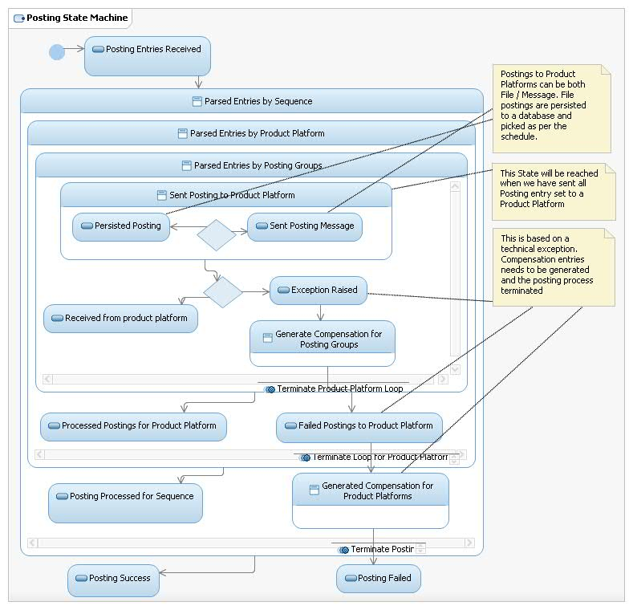

As mentioned above the entries which needs to be posted as files. Accounting hub will forward those to Transaction Bus. Transaction bus will bulk the posting entries and send it to the product platform. Accounting hub will only post the online entries to the product platform.

### Process Batch Posting

The following are the logical components required for the File Processing Solution. This solution will be used for low volume file. This solution will be used by Accounting Hub to generate the posting files for the product platforms.

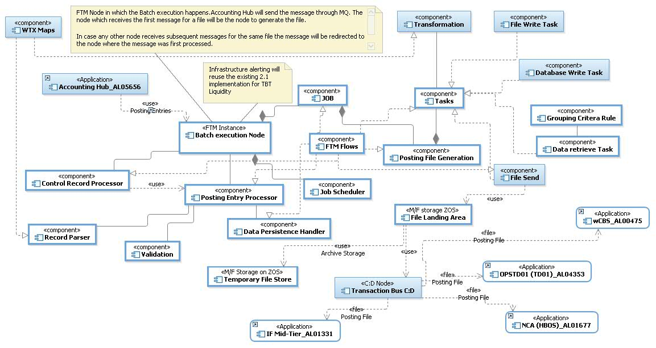

Features of the Solution:

The solution is node specific. The node to process the file is based on the availability of one of the FTM nodes. The availability is based on an available processing thread on a node. This solution is node specific.

Accounting Hub will send posting entries to Transaction Bus. One of the available instances of Transaction Bus will read the message and parse the record. Once parsed successfully the record will be persisted to its local database.

Accounting Hub will also send the control message when the file needs to be generated. This would trigger the file generation task.

The file generation task will bulk the records and to destination file format. For example for wCBS the file format will be AK350. This file generation can also be triggered on a schedule. The Job Scheduler runs the schedule. For every Job there may be a schedule configured. Accounting hub will be responsible to transform to the destination format

Once a specific type of file generation is invoked, FTM will collect all the messages of that type (which were persisted earlier). Create an outbound batch object for them and outbound transactions for them. It will pass all that information to the WTX map which will create a file and then FTM will use outbound transmission to send it to the product system.

The Job will be a combination of tasks (implemented through sub-flows).

There must be a separate task to transform the records by destination format. This will be rule based. The transformation rules will be available in all nodes. These rules are limited to file grouping rules (aka Header, detail (including contra), footer)

*The usecase for Accounting Hub is to generate the Posting entries. The posting data will be configured in Account Master Data. The data can be queries through getNPA. Alternatively the data can be exported and file joins can be used to identify the account posting entries*

Every Job, Step and Task will have common logging and auditing points. These must be wire-able through configuration settings for a particular job.

Each Job and Task will have a trigger and a controller. The trigger can be a schedule or an message event or any Job/Task completion event.

When FTM receives the control message from Accounting Hub or based on the schedule. FTM will collate the responses and will write the response file in file landing area. FTM will write a unique alert message into Syslog with batch job name. Automation will pick up the alert message from the Syslog and notify TWS, passing the job name

TWS will initiate the following:

1. A batch job will read a control file, which will contain posting file landing area path and product platform details. The batch job will read the file from the landing area and pass the filename to the ConnectDirect process.
2. A ConnectDirect job will transfer the posting file to the relevant product platform through ConnectDirect.
3. Another batch job will move the posting file from landing area to temp filestore (archive directory).

**File processing pattern**

| Pattern Name | Possible Steps | Tasks | Notes |
| --- | --- | --- | --- |
| Generate Posting File  (Accounting Hub 🡪 Product Platform) | Retrieve Posting Entries 🡪 Group Record by Sort Code/Account number 🡪 Group By product Platform 🡪 Split Record By Product Platform 🡪 Split Records by Type of Posting 🡪 Transform to product Platform Format 🡪 Record Audit in TODS | Parse Record  Record Group Task  Transform Record - to Target Format | This scenario will be executed as an extension to the online posting process. Accounting Hub will receive the posting requests. It will resolve the entries required to be posted to the product platforms.  A particular Product platform may want some/ all entries to be sent as batches. In that event Accounting Hub online process will complete the online posting request after the entries (to be posted as file) these entries will be sent to Transaction Bus.  A scheduler/trigger message will trigger which will have a retrieve task. This task will retrieve the posting records from the database and trigger the Job. (Bulker). The trigger message (aka control message) will be sent from the Accounting Hub  The common Task will be to record these postings in TODS. Each individual record will be sent to TODS with the associated file reference. The TODS audit information will be for outbound file. This data replication will be done from Transaction Bus to TODS. The pub-sub mode will be reused to deliver this. As per TBT SOC Transaction bus is writing to a topic destination the same option will be used. |

The main task for the file processing to work is to identify mutually exclusive record sets and group records based on a criteria. These must be configurable by Job. (To be clarified from Transaction Bus).

In AMD a task will be configured to retrieve the records the task will have the query injected as part of the task configuration.

The posting files can be generated with header and trailer records. Accounting Hub will control the header and trailer records. These records will be sent to the Transaction Bus as control message. On-receipt of the control message Transaction Bus will generate the file for posting to the product platforms.

Audit Handler must publish the data to TODS. This will use the TODS Pub-Sub pattern. A new Activity will be defined in TODS for these audit messages. As per TBT SOC Transaction bus is writing to a topic destination the same option will be used.

Refer to the Detail Application Architecture instructions in the Usage Model for Application Architecture in RSA (which is available on Compass). Insert the relevant diagrams into this section. See Hint and Tip RSA Diagrams – Copying or Saving.

## Sequence Diagrams for all Use Cases

The details are covered as activity flows should application / system compartments in the previous sections. This project’s main function is to post to the hHBOS product platforms. There is no enquiry requirements to the hHBOS product platforms.

### Apply Account Posting (hHBOS)

The following diagram covers the account posting basic flow. The Product Platform lifeline in the below diagram represents the hHBOS platforms. Accounting Hub will Maintain the transaction context across sytems

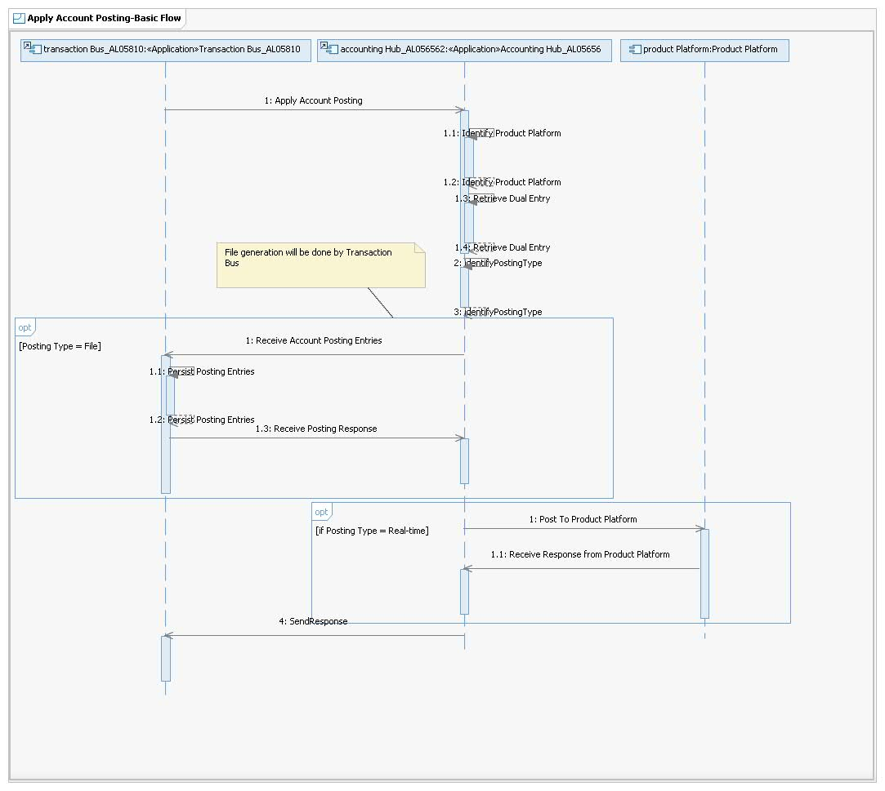

The following sequence diagram shows the flow for Inter platform settlement

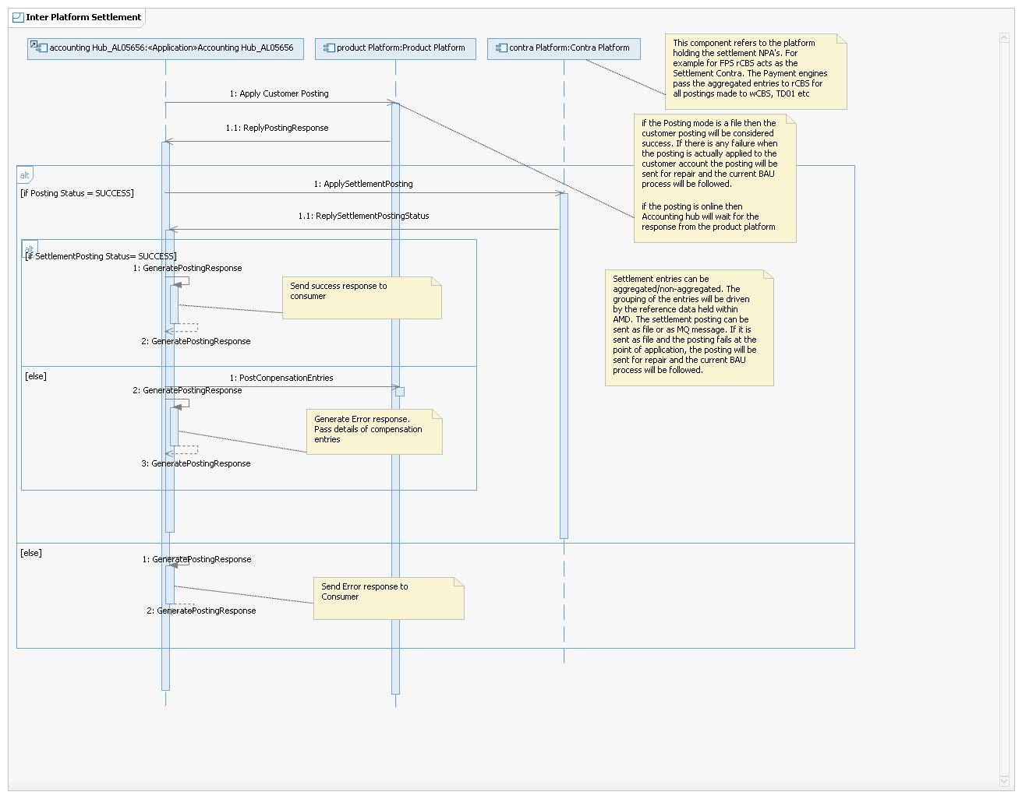

This section illustrates how the end-to-end system is expected to work by giving all of the architecturally significant use case (or scenario) elaborations and explains how the various outline design model elements contribute to their functionality.

Sequence diagrams should be provided for **all** **architecturally significant** use cases referenced in section 3.1 to demonstrate how the model elements will interact. This enables the requirements for all of the Components indicated in the previous section to be validated. See Hint and Tip RSA Diagrams – Copying or Saving.

Note: Audit data to TODS for files will be sent from Transaction Bus.

### Apply Batch Posting

This section shows the sequence diagrams required to process the batch files. The scenarios:

1. For Posting entries to be Posted as Bulk, for postings requests received as online messages from Transaction Bus. Pass the posting entries to Transaction Bus. Transaction Bus will persist the entries. Accounting Hub will transform the message to target Product platform format before sending to Transaction Bus. Transaction bus will persist the posting entries from Accounting Hub and send it to the Product Platform. Internal transformations to be avoided in Transaction bus from the Accounting Hub message.
2. Accounting Hub will also send a control message (Header, Grouped records, Trailer) to the Transaction Bus. This control message will be used by Transaction Bus to initiate the Batch Payment. This control message will be sent by Accounting Hub if the file has these entries. Else the files will be generated on schedule.
3. Bulk the posting entries from the step above group them by product platform and generate posting files for each platform. This also includes the file sending to the product platforms

The following sequence diagram shows the high level orchestration between Batch processing components. This process can be invoked either based on a Job Schedule or a trigger message from Accounting Hub.

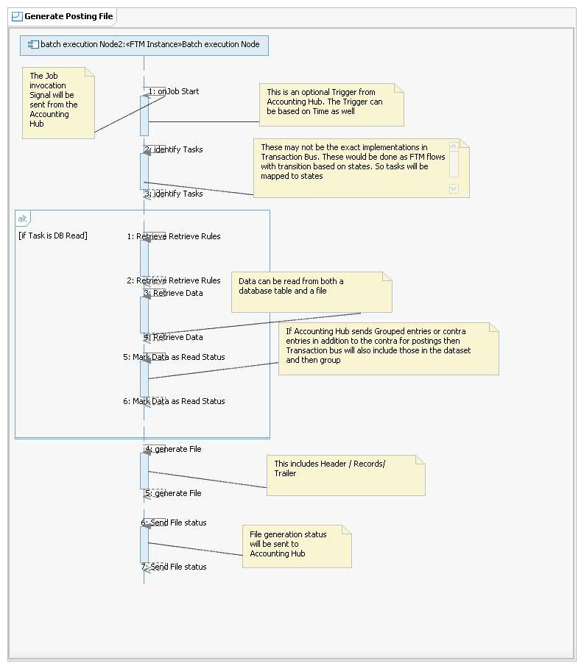

The following sequence diagram shows the flow when Accounting hub receives an online posting request from Transaction Bus and as part of its Posting entry generation it identifies the entries needs to be posted as Files to the Product platform. The entries will be sent to Transaction Bus which will persist the entries. A separate flow will pick these entries and generate files

The generation of the posting entries will be done through the AMD :GetNPA call. Accounting Hub will read the entries and identify the entries which needs to be generated as Files.

The read step will be followed by a merge step to merge all the records. The records will then be grouped by product platforms. Each of these groups will be split and separate files generated by product platforms.

Once the files are generated for the platform the files will be sent to the platform.

# Data View

This section describes the persistent data storage for the system. If there is little or no persistent data or the translation between the Design Model and the Data Model is trivial then that must be stated.

## Outline Data Elements

### Overview

The core capability of Accounting Hub project is to build a generic interface to Product Platforms. The payment engine will use Accounting Hub to identify the product platform, and will route to Accounting Hub for posting to hHBOS product platforms.

Below are the key considerations as part of this design with respect to data:

* Transaction bus (FTM) sends the Posting request to Accounting Hub. The message will be based on the IFW format and will be wrapped in a SOAP envelop. The inbound message format may undergo a change and this will not have any implication on underlying data structures within FTM.
* Accounting Hub will invoke Account Master Data (AMD) service to identify the static data for the account. The static data for accounts are temporarily stored in Account Master Data Database by utilising the existing placeholders.
* Audit information for Bulk files will be sent to TODS from Transaction Bus for facilitating enquiries in the future. Existing services will be used to publish the data into TODS by utilising the existing placeholders.

## Detail Data Elements

### Data Sourcing and Placement

|  |  |  |  |  |
| --- | --- | --- | --- | --- |
| ***Use of appropriate sources for the project's data requirements. Avoidance of use of analytical data sources for operational usage. Appropriate placement of data, in accordance with Information Architecture strategy.*** | | | | |
| How does this align with the Information Architecture Strategy (**delete as appropriate**)  Aligns with the Strategy  The’Not Applicable’ option should only be selected when this Information Design Element does not apply to the project – full rationale for this must be given below. | | | | |
| Overview of alignment with strategy | | | The design elements deals with the data where source data is found.  The data is moved and enriched on required interfaces following proper validations, exceptional handling,. No data copies are created apart from in-transit stores within the environment hence only single source is kept for particular data element | |
| The following matrix is used to show how the data will be used within the application landscape | | | | |
| ***Source Application*** | ***Logical Data Group*** | ***Target Application*** | | ***Notes on proposed usage*** |
| Transaction Bus  (AL05810) | Event | Accounting HUB  (AL05656) | | The posting transactions from Transaction Bus to accounting hub. These are real-time requests to Accounting Hub. Accounting Hub will generate the actual posting entries and pass to the product platforms. The responses will be sent back to Transaction Bus. |
|  | Agreement Event | OPSBOS (TD01)  (AL00685) | | Posting entries for customer accounts on TD01 for all payment schemes |
| Agreement Event | wCBS  (AL00475) | | Posting entries for customer accounts on wCBS for all payment schemes |
| Agreement Event | NCA(HBOS) (AL01677) | | Posting entries for customer accounts on NCA and settlement entries. |
| Event | Generic gateway  (AL04341) | | Generic Gateway (GG) uses SOAP/MQ for account enquiry from rCBS. |
| Agreement Event | IF MID_Tier (AL01331) | | Posting entries for customer accounts.  Accounting Hub will route to IF-Midtier, and IF-Midtier forwards it to the IF Platforms |
| Event | TODS | | Posting Entries collected in a file, and Posting Request and Response will be replicated on TODS from Transaction Bus.  For posting entries collected in a posting file will be replicated by PUB-SUB pattern |

#### Logical Data Groups

There is no change to any of the application logical data groups for the impacted systems.

Pl. note that the enquiry services for these product platforms are not delivered as part of this project hence the respective LDG’s are not captured as part of the below table.

The Troux matrix showing the CRUDMA mappings for the applications in scope is inserted here. The changes made to the Troux mappings must be highlighted in red.

| **Application Details** | | **Logical Data Group** | | | **Impact Type** | | | | | |
| --- | --- | --- | --- | --- | --- | --- | --- | --- | --- | --- |
| **Application Name** | **Application ID** | **Level A** | **Level B** | **Level C** | **M** | **R** | **C** | **U** | **D** | **A** |
| Transaction Bus | AL05810 | Agreement | Product Agreement | Payment Instruction | N | Y | N | N | N | N |
| Transaction Bus | AL05810 | Event | Financial Transactions |  | N | Y | N | N | N | N |
| Transaction Bus | AL05810 | Event | Financial Transactions | Payment Settlement | N | Y | N | N | N | N |
| Transaction Bus | AL05810 | Internal Organisation | Organisation | Internal Organisation Business Rules | N | Y | N | N | N | N |
| Transaction Bus | AL05810 | Reference Data |  |  | N | Y | N | N | N | N |
| Accounting Hub | AL05656 | Event | Financial Transactions |  | N | Y | N | Y | N | N |
| Accounting Hub | AL05656 | Event | Financial Transactions | Current (Customer) Account Payment | N | Y | N | Y | N | N |
| Transactional Operational Data Services | AL05887 | Channel |  |  | N | Y | Y | N | N | Y |
| Transactional Operational Data Services | AL05887 | Channel | Channel Type |  | N | Y | Y | N | N | Y |
| Transactional Operational Data Services | AL05887 | Event |  |  | N | Y | Y | N | N | Y |
| Transactional Operational Data Services | AL05887 | Event | Financial Transactions |  | N | Y | Y | N | N | Y |
| Transactional Operational Data Services | AL05887 | Event | Financial Transactions |  | N | Y | Y | N | N | Y |
| Transactional Operational Data Services | AL05887 | Reference Data |  |  | N | Y | Y | N | N | Y |
| Transactional Operational Data Services | AL05887 | Reference Data | Look-up Data |  | N | Y | Y | N | N | Y |
| NCA (HBOS) | AL01677 | Agreement |  |  | N | Y | N | N | N | N |
| NCA (HBOS) | AL01677 | Finance |  |  | N | N | Y | N | N | N |
| NCA (HBOS) | AL01677 | Party |  |  | N | Y | N | N | N | N |
| NCA (HBOS) | AL01677 | Product |  |  | N | Y | N | N | N | N |
| wCBS | AL00475 | Agreement |  |  | N | Y | N | N | N | N |
| wCBS | AL00475 | Finance |  |  | N | N | Y | N | N | N |
| wCBS | AL00475 | Party |  |  | N | Y | N | N | N | N |
| wCBS | AL00475 | Product |  |  | N | Y | N | N | N | N |
| wCBS | AL00475 | Product | Product Rules |  | N | Y | Y | Y | N | N |
| IF Mid-Tier | AL01331 | Agreement |  |  | N | Y | Y | N | N | N |
| IF Mid-Tier | AL01331 | Agreement | Application | Customer Application Details | N | Y | Y | N | N | N |
| IF Mid-Tier | AL01331 | Agreement | Application | Product Application Details | N | Y | Y | N | N | N |
| IF Mid-Tier | AL01331 | Agreement | Product Agreement |  | N | Y | Y | Y | N | N |
| IF Mid-Tier | AL01331 | Agreement | Product Agreement | Mortgage Agreement Details | N | Y | Y | Y | N | N |
| IF Mid-Tier | AL01331 | Agreement | Product Agreement | Savings Account Agreement Details | N | Y | Y | Y | N | N |
| IF Mid-Tier | AL01331 | Channel |  |  | N | Y | N | N | N | N |
| IF Mid-Tier | AL01331 | Channel | Channel Type | Telephony Channel | N | Y | N | N | N | N |
| IF Mid-Tier | AL01331 | Channel | Channel Type | Web Channel | N | Y | N | N | N | N |
| IF Mid-Tier | AL01331 | Event |  |  | N | Y | Y | Y | N | N |
| IF Mid-Tier | AL01331 | Event | Financial Transactions |  | N | Y | Y | Y | N | N |
| IF Mid-Tier | AL01331 | Event | Financial Transactions | Current (Customer) Account Payment | N | Y | Y | N | N | N |
| IF Mid-Tier | AL01331 | Event | Financial Transactions | Mortgage Account Payment | N | Y | Y | N | N | N |
| IF Mid-Tier | AL01331 | Event | Party Event | Contact History | N | Y | N | N | N | N |
| IF Mid-Tier | AL01331 | Event | Product Agreement Event | Mortgage Maintenance Events | N | N | Y | N | N | N |
| IF Mid-Tier | AL01331 | Event | Product Agreement Event | Savings Account Maintenance Events | N | N | Y | N | N | N |
| IF Mid-Tier | AL01331 | Location | Electronic Address |  | N | Y | N | N | N | N |
| IF Mid-Tier | AL01331 | Location | Point Address |  | N | Y | N | N | N | N |
| IF Mid-Tier | AL01331 | Party | Customer |  | Y | Y | Y | Y | N | N |
| IF Mid-Tier | AL01331 | Party | Customer | Customer Additional Details | N | Y | Y | Y | N | N |
| IF Mid-Tier | AL01331 | Party | Customer | Individual Name Details | N | Y | Y | Y | N | N |
| IF Mid-Tier | AL01331 | Party | Customer Agent |  | N | Y | Y | Y | N | N |
| IF Mid-Tier | AL01331 | Party | Ex-customer |  | N | Y | Y | Y | N | N |
| IF Mid-Tier | AL01331 | Party | Ex-customer | Personal Ex-Customer | N | Y | N | N | N | N |
| IF Mid-Tier | AL01331 | Party | Prospect | Personal Prospect | N | Y | Y | Y | N | N |
| IF Mid-Tier | AL01331 | Product | Product Definition |  | N | Y | Y | Y | N | N |
| IF Mid-Tier | AL01331 | Product | Product Features |  | N | Y | Y | Y | N | N |
| IF Mid-Tier | AL01331 | Product | Product Rules |  | N | Y | Y | Y | N | N |

### Data Models

|  |  |
| --- | --- |
| ***Data Models document and organize data in terms of how it is stored and accessed, as well as define the relationships between different data components. Varying Data models are used at different stages of a project lifecycle but are all intrinsically linked.*** | |
| How does this align with the Data Model Strategy (**delete as appropriate**):  Aligns with the Strategy The’Not Applicable’ option should only be selected when this Information Design Element does not apply to the project – full rationale for this must be given below. | |
| Overview of alignment with strategy | Applications do account posting to product platforms where data is being persisted within each product platform. There is no change to the product platform underlying data structures hence data model is not included as part of this AD.  The Audit information sent from transaction hub is captured in TODS. There won’t be any change to the underlying TODS datamodel and the existing services (using MQ Protocol) will be reused to publish the data into TODS. |
| Rationale for including a data model | Not applicable |

#### Logical Data Model and Supporting Information

- Not Applicable.

### Metadata

|  |  |
| --- | --- |
| ***“Metadata is information that describes or provides context for data, content, business processes, services, business rules, and policies that support an organization’s information systems“*** | |
| How does this align with the Metadata Strategy (**delete as appropriate**):  Aligns with the Strategy  The’Not Applicable’ option should only be selected when this Information Design Element does not apply to the project – full rationale for this must be given below. | |
| Overview of alignment with strategy | TODS records the complete metadata details for the Audit information being captured for outbound files which is in alignment with Enterprise ODS principles. |

#### Metadata Approach

This project will utilise the existing Metadata capabilities within TODS and there is no need for modifying or enhancing that feature.

### Data Retention and Archival

|  |  |
| --- | --- |
| ***Data retention defines the policies for persisting data in order to comply with either legal, regulatory or project requirements. Data Archival is mechanism by which data retention can be achieved.*** | |
| How does this align with the Data Retention and Archival Strategy (**delete as appropriate**):  Aligns with the Strategy  The’Not Applicable’ option should only be selected when this Information Design Element does not apply to the project – full rationale for this must be given below. | |
| Overview of alignment with strategy | State the rationale for how the project aligns with, moves towards or does not align with strategy for data retention and archival. Where applicable, ensure this reasoning is suitably represented in the Architecture Decisions section of the document.TODS holds current data to support ‘run the business’ activity, archiving driven by business requirements and group records policy. |

#### Data Retention and Archival Approach

* The Accounting Hub project expects the Audit data to be persisted within TODS and

TODS complies with group records policy and have a specified retention period. Usually TODS holds current data (typically up to 25 months old) for operational purposes when data expires on T-ODS it is removed to an archive as necessary

* TODS data archive complies with the group data archiving reference architecture. Data that has expired from T-ODS can be retained on an archive store provided there is a business requirement from business data owner.

*Include a description of the project’s approach to data retention and archival. The description includes (but is not limited to) the following points:*

* ***Full details about the data retention and archival aspects of this project***
* *How long this project requires the data to be retained for and how it will be deleted once it has passed its retention period.*
* *Details of which applications currently archive the data relevant to this project (expressed in terms of the logical data groups).*
* *The archival tool to be used by the project*
* *A description of how the archive data will be accessed in BAU*
* *The volume of data to be archived*
* *The frequency at which the data will be archived (e.g. weekly, monthly, yearly)*

### Data Quality

|  |  |
| --- | --- |
| ***Data Quality is the banner under which data is managed to assess its accuracy, completeness, validity, timeliness and consistency. Whereas Data profiling is the systematic upfront analysis of the content of a data source and is an audit requirement.*** | |
| How does this align with the Data Quality Strategy (**delete as appropriate**):  Aligns with the Strategy  The’Not Applicable’ option should only be selected when this Information Design Element does not apply to the project – full rationale for this must be given below. | |
| Overview of alignment with strategy | All the data groups are either fetched from the master source at real-time, or provided by business and loaded as one-time load.  Posting entries has a low frequency of change and will be controlled through the CR process on Accounting Hub This data will be modified created within the scope of the payment engines. |

#### Data Quality Approach

This project receives the data from the interlocking applications and it expects the data to be in the desired format.

### Reference Data

|  |  |
| --- | --- |
| ***Reference data is defined as: “Data held in a system that is often stable (i.e. low volatility) and maintainable via specifically created maintenance tools and/or processes, and is referred to by the Group for efficient operation."*** | |
| How does this align with the Reference Data Strategy (**delete as appropriate**):  Aligns with the Strategy The’Not Applicable’ option should only be selected when this Information Design Element does not apply to the project – full rationale for this must be given below. | |
| Overview of alignment with strategy | Account Master Data (AMD) will be responsible to resolve the product platform for all accounts in the request. . Accounting Hub will invoke this service to identify the static data for the account . |

#### Reference Data Approach

* AMD maintains some additional reference data required during message transformation. These will be used to populate the message before sending to the product platforms.
* The reference data is stored temporarily for 7 days in Oracle Database beyond that it will be deleted. The underlying database design for this reference data is already existing and accounting hub project is making use of the underlying data structures.
* All reference data within AMD including getNPA will be cached to reduce load on the databases. There will be only a data-cache scale used as L2 cache.

### Analytics & Reporting

|  |  |
| --- | --- |
| ***The use of data to derive insights and discern business trends or patterns, including the production of reports*** | |
| How does this align with the Analytics and Reporting Strategy (**delete as appropriate**):  Not applicable  The’Not Applicable’ option should only be selected when this Information Design Element does not apply to the project – full rationale for this must be given below. | |
| Overview of alignment with strategy | There is no reporting requirement in scope of this project. |

#### Analytics & Reporting Approach

- Not Applicable

### Unstructured Data

|  |  |
| --- | --- |
| ***Unstructured Data refers to the type of data which lacks the standardised logical data structures or models which makes it difficult to easily consume by IT systems.*** | |
| How does this align with the Unstructured Data Strategy (**delete as appropriate**):  Not applicable  The’Not Applicable’ option should only be selected when this Information Design Element does not apply to the project – full rationale for this must be given below. | |
| Overview of alignment with strategy | This solution design doesn’t cater for any unstructured data |

#### Unstructured Data Approach

- Not Applicable.

### Data Integration

|  |  |
| --- | --- |
| ***Data Integration is the movement and transformation of data in both batch and real-time modes.*** | |
| How does this align with the Data Integration Strategy (**delete as appropriate**):  Aligns with the Strategy  The’Not Applicable’ option should only be selected when this Information Design Element does not apply to the project – full rationale for this must be given below. | |
| Overview of alignment with strategy | Accounting Hub Project handles data Transformation for Account posting and Enquiries. The tool used for data transformation, data movement and access is IBM Message Broker. Transaction Bus will use WTX for transformation |

#### Data Integration Approach

* Accounting Hub will transform the messages as per the agreed schema with the product platforms and the consuming applications.
* Transaction Bus will invoke the TODS service to push audit information to TODS for online/batch postings

# Infrastructure View

**hHBOS Product Platforms**

* wCBS (AL00475)
* OPSBOS TD01 (AL00685)
* iF-Mid-Tier (AL01331)

Core components to be delivered as part of this project is the connectivity to the hHBOS Product Platforms from the Accounting Hub (AL05656) & Transaction Bus (AL05810) to wCBS (AL00475), iF-Mid-Tier (AL01331), OPSBOS TD01 (AL00685) using C:D Secure+ and MQ. These interfaces will be both batch and online. No new infrastructure will be introduced.

The project will reuse the existing MQ interfaces and C:D nodes on the hHBOS Product Platforms. The project will only change the route of the CHAPS and International transactions to the hHBOS Product Platforms. Changes are required on the Accounting Hub to enable it to send the posting messages via MQ and Transaction Bus to send the posting files via C:D. There will be no additional traffic on the hHBOS platforms, the additional traffic on Accounting Hub will be close to 1 thousand posting transactions per day (refer to table below)

|  |  |  |  |
| --- | --- | --- | --- |
| Payment Scheme | Account enquiry (day) | Account Posting (day) | Time window |
| International | 800 | 800 | Chaps processing window (5:30AM to 4:30PM) |
| CHAPS | 50 | 50 | International processing window(6AM to 7PM) |

## Outline Infrastructure Elements

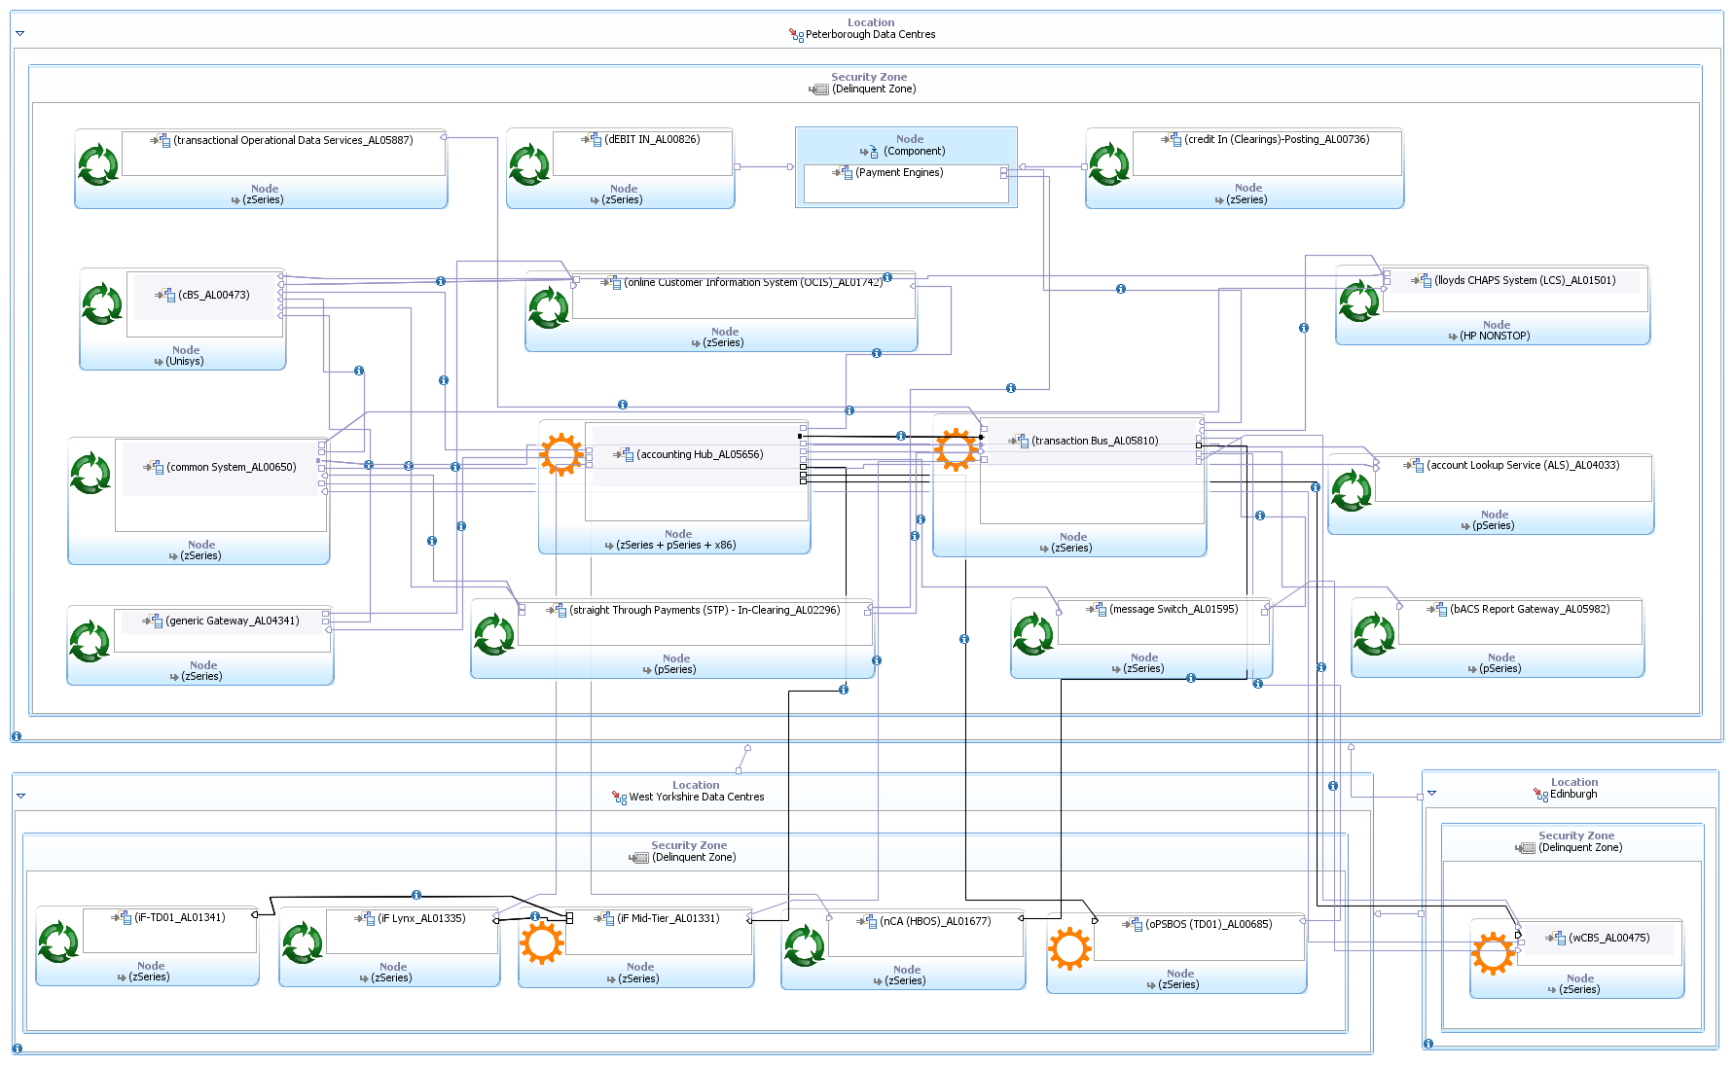

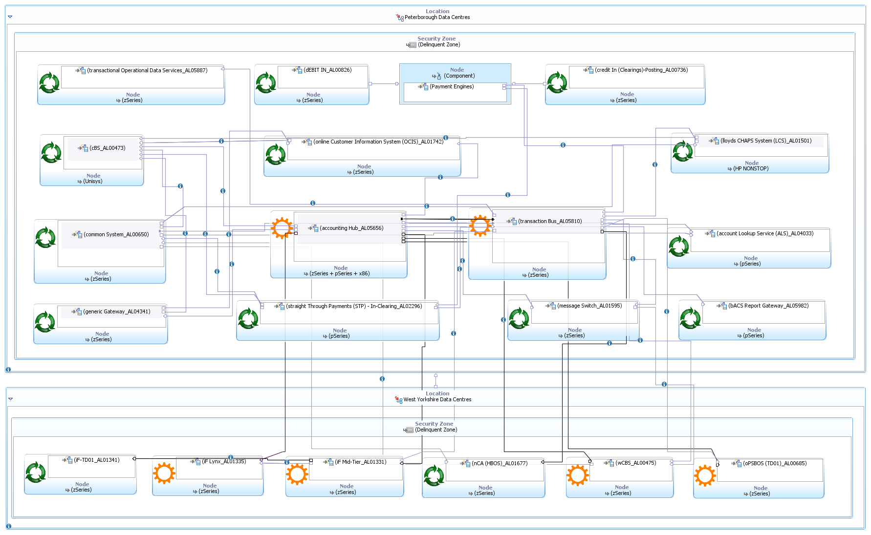Refer to the Outline Infrastructure Architecture instructions in the Usage Model for Infrastructure Architecture in RSA (which is available on Compass).

Insert the relevant diagram into this section. See Hint and Tip RSA Diagrams – Copying or Saving.

* + 1. **Outline Infrastructure Impact**

Update the Infrastructure impact table with the relevant infrastructure impacts as described in the Outline Infrastructure Impact guidance on Compass. Mark all rows “Not Applicable” if not impacted.

| **Technical Platform** | **Sub-Platform** | **Impact** | **Comments** |
| --- | --- | --- | --- |
| Mainframe | IBM System z - Linux | Change | **MQ Configuration changes for Accounting Hub (AL05656)**  For requests to wCBS (AL00475), iF-Mid-Tier (AL01331), OPSBOS TD01 (AL00685), alias queues need to be created on Accounting Hub queue manager and queues need to be created on wCBS, iF-Mid-Tier, OPSBOS TD01, For response from wCBS, iF-Mid-Tier, OPSBOS TD01. Alias queues need to be created on wCBS, iF-Mid-Tier, OPSBOS TD01 queue managers and queues need to be created on Accounting Hub queue manager. |
| IBM System z - zOS | Change | **MQ Configuration changes for wCBS (AL00475),** Alias queue to be created in existing Queue Manager to respond to the newly created interface with Accounting Hub (AL05656) – ConnectDirect node to be configured to interface with Transaction Bus (FTM) |
| IBM System z - zOS | Change | **MQ Configuration changes for iF-Mid-Tier (AL01331**), Alias queue to be created in existing Queue Manager to respond to the newly created interface with Accounting Hub (AL05656) – ConnectDirect node to be configured to interface with Transaction Bus (FTM) |
| IBM System z - zOS | Change | **MQ Configuration changes for OPSBOS TD01 (AL00685),** Alias queue to be created in existing Queue Manager to respond to the newly created interface with Accounting Hub (AL05656) – ConnectDirect node to be configured to interface with Transaction Bus (FTM) |
| IBM System z - zOS | Change | **Transaction Bus (AL05810)** - C:D node on z/OS - Transaction Bus (AL05810) will send a new file using C:D node on z/OS to C:D Server on z/OS for wCBS (AL00475), iF-Mid-Tier (AL01331), OPSBOS TD01 (AL00685) using C:D Secure+ |
| IBM System z - zOS | Reuse | No change is needed for **Transactional Operational Data Services (TODS) (AL05887)** Audit information for Bulk files will be sent to TODS from Transaction Bus using the strategic pub-sub pattern delivered for TBT SOC by TODS. Reuse the qmanagers delivered for TBT SOC |
| IBM System z - zOS | Reuse | No change is needed for **NCA (AL01677)** Accounting hub will send the files to NRT Proxy through Transaction Bus which in turn will generate the NCA postings |
| IBM System z - zOS | Reuse | No change is needed for  **IF Lynx (AL01335)** Accounting Hub will route to IF Mid-Tier, and IF Mid-Tier forwards it to the IF Lynx |
| IBM System z - zOS | Reuse | No change is needed for  **IF-TD01 (AL01341)** Accounting Hub will route to IF Mid-Tier, and IF Mid-Tier forwards it to the IF-TD01 |
| IBM System z - zOS | Reuse | **Online Customer Information System - OCIS (AL00473)** Instead of Accounting Hub services to invoke OCIS via an api it will be invoked by Account Posting Services (AL06614) Account Master Data (AMD) no change to OCIS. |
| IBM System z - zOS | Reuse | No change is needed for **Common System (AL00650)** Existing MQ interface with Accounting Hub (AL05656) used |
| IBM System z - zOS | Reuse | **Generic Gateway (AL04341)** Existing MQ interface with Accounting Hub (AL05656) used |
| IBM System z - zOS | Reuse | **Message Switch (AL01595)** Interface to hHBOS platforms, this interface can be used for faster payment postings to wCBS**.** |
|  |  |  |
|  |  |  |
| Unisys - Dorado OS2200 | Reuse | **rCBS (AL00473)** As part of this project Account Posting Services (AL06614) Account Master Data (AMD) must deliver the availability service to rCBS. The design for this service is already approved. |
|  |  |  |

|  |  |  |  |
| --- | --- | --- | --- |
| Mid-range |  |  |  |
| System p - AIX | Reuse | **Account Lookup service- ALS (AL04033)** Instead of Accounting Hub services to invoke ALS via an api it will be invoked by Account Posting Services (AL06614) Account Master Data (AMD) no change to ALS. |
| System p - AIX | Reuse | **BACS Report Gateway (AL05982)** Account Posting Services (AL06614) Account Master Data (AMD) to invoke BACS report Gateway to identify whether an account is switched out. |
|  |  |  |
| x86 Server | x86 - Linux |  | **Accounting Hub (AL05656)** Account Master Data (AMD) a separate application as part of the Accounting Hub To store the reference data. AMD provides Retrieve Additional Details Service this service will integrate with OCIS in scope for this project. The call is a HTTPS call to OCIS. |
| x86 - Windows |  | N/A |
| Appliance | DataPower |  | N/A |
| Black box |  | N/A |
| Role | Presentation (Internet) |  | N/A |
| Presentation (Intranet/Portal) |  | N/A |
| Application Hosting |  |  |
| Database | Reuse | Reuse of DB2 10.2 - Transaction Bus (AL05810) & Oracle 11gR2 Account Posting Services (AL06614) Account Master Data (AMD) |
| File Serving |  | N/A |
| Collaboration Services |  | N/A |
| Directory Services |  | N/A |
| Centralised Printing/Scanning |  | N/A |
| Client | Head Office |  | N/A |
| Branch |  | N/A |
| Hybrid (Head Office-Branch) |  | N/A |
| Application Hosting (Citrix) |  | N/A |
| Desktop Hosting (VMware VDI) |  | N/A |
| Local Printing/Scanning |  | N/A |
| Network | WAN | Reuse | WAN between West Yorkshire, Edinburgh & Peterborough will be reused. Low daily transaction volumes as a result of this project will not be an issue for the network. |
| Data centre LAN | Reuse | Data Centre LAN will be reused. |
| Office/Branch LAN |  | N/A |
| 3rd Party Links |  | N/A |
| Telephony |  | N/A |
| Internet / DMZ |  | N/A |
| Systems and Service Management | Software Distribution - Client |  | N/A |
| Software Distribution - Server |  | N/A |
| Patch Management | Reuse. | Use existing tools and methods for the platforms. |
| Job Scheduling | New | New batch job in mainframe has to be scheduled using Tivoli Workload Scheduler (TWS) to move the request file from request File Landing Area to request File Processing Area on z/OS.  New batch job in mainframe has to be scheduled using Tivoli Workload Scheduler to read the response file from the response landing area and pass the filename to the C:D server on z/OS.  New batch job in mainframe has to be scheduled using Tivoli Workload Scheduler to move the response file from response File Landing Area to File Store on z/OS after successful processing of the response file |
| Remote Control |  | N/A |
| File Transfer | New | ConnectDirect file transfer - C:D node on z/OS - Transaction Bus (AL05810) will send a new file using C:D node on z/OS to C:D Server on z/OS for wCBS (AL00475), IF Mid-Tier (AL01331), OPSBOS TD01 (AL00685) using C:D Secure+ |
| OS Monitoring and Alerting | Reuse | Existing z/OS, AIX, z/Linux monitoring will be reused |
| Business Availability Monitoring |  | N/A |
| Synthetic End to End Monitoring |  | N/A |
| Real End User Monitoring |  | N/A |
| Dependency Mapping |  | N/A |
| Application Monitoring and Alerting | Reuse | Use existing tools and methods for the platforms |
| Storage & Backups | IBM Enterprise Storage | Reuse | Low daily transaction volumes as a result of this project will not require additional storage. |
| HP EVA |  | N/A |
| Hitachi Storage | Reuse | Low daily transaction volumes as a result of this project will not require additional storage. |
| NetBackup |  | N/A |
| TSM Backup |  | N/A |
| EMC Centera |  | N/A |
| NetApp |  | N/A |
| Data centres | Horizon Centre |  | N/A |
| Peterborough | Reuse | Peterborough Data centres will be reused |
| West Yorkshire | Reuse | West Yorkshire Data centres will be reused |
| Distributed Tech Room |  | N/A |
| Treasury & Markets |  | N/A |
| Scottish Widows (Edinburgh) | Reuse | Data centre will be reused - wCBS |
| Europe |  | N/A |
| North America |  | N/A |
| Asia |  | N/A |
| 3rd Party External |  | N/A |

## Detail Infrastructure Elements

The Physical model depicts the changes highlighted in the above Outline Infrastructure Impact

**MQ Configuration changes for Accounting Hub**

For requests to wCBS, IF Mid-Tier, OPSBOS TD01, alias queues need to be created on Accounting Hub queue manager and queues need to be created on wCBS, IF Mid-Tier, OPSBOS TD01, For response from wCBS, iF-Mid-Tier, OPSBOS TD01. Alias queues need to be created on wCBS, IF Mid-Tier, OPSBOS TD01 queue managers and queues need to be created on Accounting Hub queue manager.

**Connect Direct configurations for Transaction Bus**

C:D node on z/OS - Transaction Bus will send a new file using C:D node on z/OS to C:D Server on z/OS for wCBS, IF Mid-Tier, OPSBOS TD01 using C:D Secure+

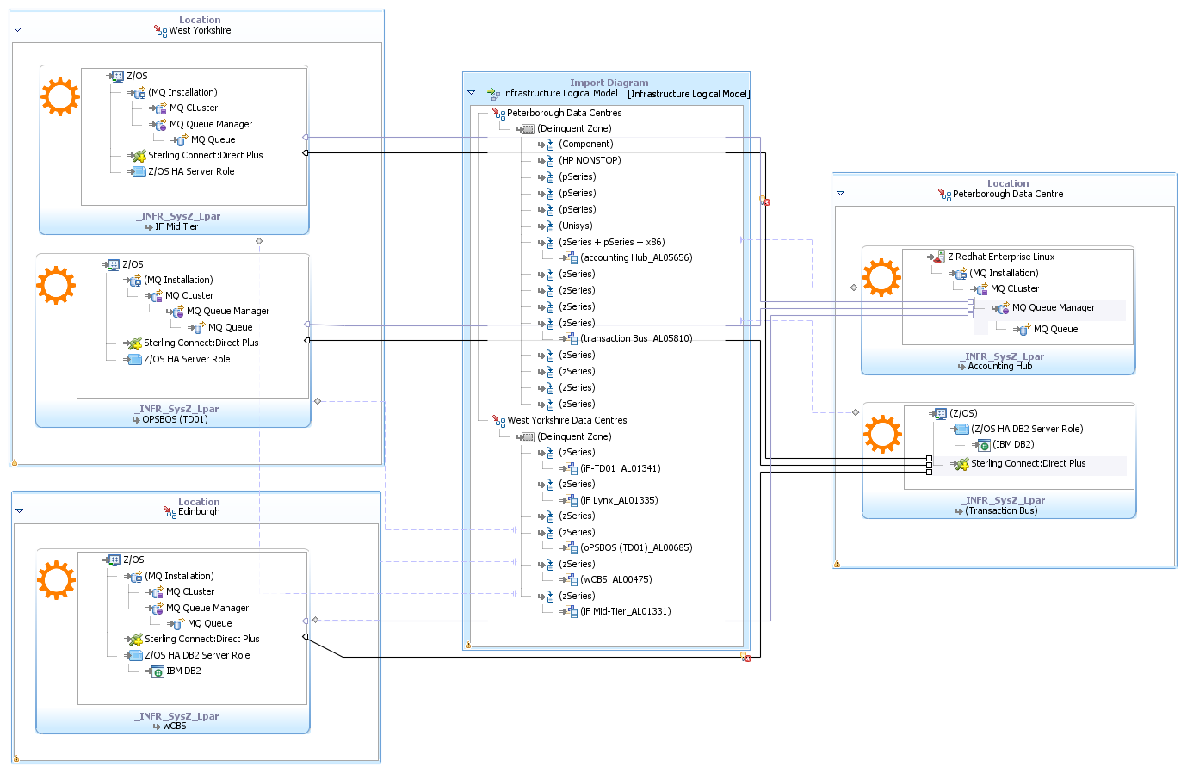

* + 1. **Detail Centralised Infrastructure Impact**

| **Service Component** | **Quantity** | **Project Impact** | **Initial Hosting Decision** | **Final Hosting Decision** | **Pattern** | **Sub-Pattern** | **Hardware Variance to Policy and Patterns** | **Software Variance to Policy and Patterns** |
| --- | --- | --- | --- | --- | --- | --- | --- | --- |
| Accounting Hub | Existing | New interfaces | z/Linux | z/Linux | * z Linux Workload Hosting Technology Pattern * Group IT RHEL Standard * LBG IT File Transfer Security Standard * Data Centre Technology Pattern * LBG IT Websphere MQ Security Standard | | | |
| Transaction Hub | Existing | New interfaces | zOS | zOS | * Data Centre Technology Pattern * System z zOS Platform Pattern * LBG IT File Transfer Security Standard * LBG SOAP Message Standard * LBG IT IMS and DB2 IT Security Standard | | | |
| wCBS | Existing | New interfaces | zOS | zOS | * Data Centre Technology Pattern * System z zOS Platform Pattern * LBG IT File Transfer Security Standard * LBG SOAP Message Standard * LBG IT IMS and DB2 IT Security Standard | | | |
| OPSBOS TD01 | Existing | New interfaces | zOS | zOS | * Data Centre Technology Pattern * System z zOS Platform Pattern * LBG IT File Transfer Security Standard * LBG SOAP Message Standard * LBG IT IMS and DB2 IT Security Standard | | | |
| IF Mid-Tier | Existing | New interfaces | zOS | zOS | * Data Centre Technology Pattern * LBG IT Websphere MQ Security Standard * System z zOS Platform Pattern * LBG IT File Transfer Security Standard * LBG SOAP Message Standard | | | |

* + 1. **Detail Client Infrastructure Impact**

No client or browser actions in scope for this project.

| **Service Component** | **Quantity** | **Project Impact** | **Initial Hosting Decision** | **Final Hosting Decision** | **Pattern** | **Hardware Variance to Policy and Patterns** | **Software Variance to Policy and Patterns** |
| --- | --- | --- | --- | --- | --- | --- | --- |
| N/A | N/A | N/A | N/A | N/A | N/A | N/A | N/A |

* + 1. **Detail Network Infrastructure Impact**

| **Network Component** | **Project Impact** | **Location** | **Type** | **Quantity/Scale** | **Pattern** | **Standard** |
| --- | --- | --- | --- | --- | --- | --- |
| Wide Area Networking (WAN) | New – minimal to no impact. Very low volumes across the Wan not putting a strain on the network | Peterborough, Edinburgh & West Yorkshire Data Centres | Connect Direct  MQ | New Connect direct and MQ traffic from Peterborough zSeries mainframes to West Yorkshire z Series mainframes | Voice and Data Network Domain - WAN Technology Pattern & Data Centre Technology Pattern | QOS Standard |
| Local Area Networking (LAN) | Use Existing - minimal to no impact. Very low volumes between system components | Peterborough | System interfaces | N/A | Voice and Data Network Domain Pattern & Data Centre Technology Pattern | QOS Standard |
| Network Services (IP Address Management, DNS, DHCP, NTP) | N/A | N/A | N/A | N/A | N/A | N/A |
| Network Security Infrastructure | N/A | N/A | N/A | N/A | N/A | N/A |
| Contact Centre Telephony | N/A | N/A | N/A | N/A | N/A | N/A |
| *If required, provide further supporting context and background here* |  | This project will not add any additional strain on the network due to the small daily volumes and generated traffic. | | | | |

* + 1. **Detail Systems Management Impact**

| **Component** | **Platform (OS/Appliance)** | **Location** | **Type** | **Quantity/ Scale** | **Application/ System/ Service/**  **Business Process** | **Pattern** | **Standard** | **Project Impact** |
| --- | --- | --- | --- | --- | --- | --- | --- | --- |
| Software Distribution - Client | N/A | N/A | N/A | N/A | N/A | N/A | N/A | N/A |
| Software Distribution - Server | N/A | N/A | N/A | N/A | N/A | N/A | N/A | N/A |
| Patch Management | zOS & z/Linux | Peterborough & West Yorkshire Data Centres | zSeries |  | * Accounting Hub * Transaction Bus * IF Mid-Tier * wCBS * OPSBOS | Existing standard platform patch management for zOS & z/Linux – No change | | |
| Job Scheduling | zOS | Peterborough & West Yorkshire Data Centres | Connect: Direct Secure+ | 10 | Tivoli Workload scheduler | New batch job in mainframes have to be scheduled using Tivoli Workload Scheduler (TWS) to move the request file from request File Landing Areas to request File Processing Areas on z/OS.  New batch jobs in mainframes have to be scheduled using Tivoli Workload Scheduler to read the response file from the response landing area and pass the filename to the C:D server on z/OS.  New batch job in mainframe has to be scheduled using Tivoli Workload Scheduler to move the response file from response File Landing Area to File Store on z/OS after successful processing of the response file | | |
| OS Monitoring and Alerting | zOS & z/Linux | Peterborough & West Yorkshire Data Centres | zSeries | 10 |  | Existing standard OS monitoring for zOS & z/Linux – No change | | |
| Infrastructure Monitoring and Alerting | zSeries | Peterborough & West Yorkshire Data Centres | Mainframe | 10 |  | Existing standard infrastructure monitoring for zSeries Mainframes – No change | | |
| Infrastructure Application Monitoring | zOS | Peterborough & West Yorkshire Data Centres | WebSphere MQ |  | * Accounting Hub * Transaction Bus * IF Mid-Tier * wCBS * OPSBOS | Configure existing Tivoli Omegamon for Messaging on z/OS to monitor new MQ | | |
| Infrastructure Application Monitoring | zOS | Peterborough & West Yorkshire Data Centres | WebSphere Message Broker |  | * Accounting Hub * Transaction Bus * IF Mid-Tier * wCBS * OPSBOS | Configure existing Tivoli Omegamon for Messaging on z/OS to monitor new MQ | | |
| Infrastructure Application Monitoring | z/Linux & zOS | Peterborough & West Yorkshire Data Centres | Connect Direct Sterling |  | * Accounting Hub * Transaction Bus * IF Mid-Tier * wCBS * OPSBOS | C:D monitoring is needed to manually review the logs to check the file transfer status | | |

* + 1. **Detail Service Management Impact**

There are no requirements which would necessitate the level of monitoring afforded by the HP BAC suite**.**

| **Application, System, Service, or Business Process Name** | **Dependency Mapping (Number of Hosts)** | **Synthetic Monitoring** | **Real User Monitoring** | **Business Application Monitoring** | **Business Transaction Monitoring** | **Message Catalogue Updates** | **OLA and SLA Reference** |
| --- | --- | --- | --- | --- | --- | --- | --- |
| N/A | N/A | N/A | N/A | N/A | N/A | N/A | N/A |

* + 1. **Detail Storage Impact**

No new or additional storage requirement

| **Service Component** | **Project Impact** | **Hardware Platform** | **Location** | **Requested Initial Allocation** | **% Expected Growth** | **Pattern or Standard** | **System Availability** | **Performance Required** | | **Data Archiving Cutoff** | **Replication** |
| --- | --- | --- | --- | --- | --- | --- | --- | --- | --- | --- | --- |
| Standard or High | Connectivity (2,4 or 8) |
| N/A | N/A | N/A | N/A | N/A | N/A | N/A | N/A | N/A | N/A | N/A | N/A |

* + 1. **Detail Storage Back-up Impact**

| **Service Component** | **Project Impact** | **Platform** | **Frequency** | **Retention** | **Backup Window** | **Initial Backup Size** | **% Daily Change** | **LAN Free, LAN or remote/WAN** | **SNAP** | **Replication** |
| --- | --- | --- | --- | --- | --- | --- | --- | --- | --- | --- |
| N/A | N/A | N/A | N/A | N/A | N/A | N/A | N/A | N/A | N/A | N/A |

* + 1. **Detail Messaging and Collaboration Impact**

| **Component** | **Impact** | **Recipient and Users** | | **Volume** | **Pattern** | **Standard** | **Frequency and Schedule** |
| --- | --- | --- | --- | --- | --- | --- | --- |
| Email | N/A | N/A | | N/A | N/A | N/A | N/A |
| EMail Journaling | N/A | N/A | | N/A | N/A | N/A | N/A |
| Instant Messaging | N/A | N/A | | N/A | N/A | N/A | N/A |
| File Share | N/A | N/A | | N/A | N/A | N/A | N/A |
| SharePoint Applications | N/A | N/A | | N/A | N/A | N/A | N/A |
| Intranet | N/A | N/A | | N/A | N/A | N/A | N/A |
|  | | **Source** | **Target** |  | | | |
| File Transfer | N/A | N/A | N/A | N/A | N/A | N/A | N/A |
| FAX | N/A | N/A | N/A | N/A | N/A | N/A | N/A |
| Automated SMTP | N/A | N/A | N/A | N/A | N/A | N/A | N/A |

## Environment Overview

The below tables depict the RTL environments available for Accounting Hub & Transaction Bus.

Complete the following table in accordance with the guidance available. Further information about the Environment Overview is available [here](http://hbos.intranet.local/gito/adf/COMPASS2/DesignArtefactPages/Environment%20Overview.aspx).

**Transaction Bus**

|  |  |  |  |  |
| --- | --- | --- | --- | --- |
| **Environment Category** | **Route to Live Environment Name** | **Environment Use** | **Project Impact** | **Description** |
| Development / Local Test | DEV2 | Development | Existing | Transaction Bus |
| Formal Test | ST2 | Formal Test - System Test | Existing | Transaction Bus |
|  | SIT2 | Formal Test - SIT | Existing | Transaction Bus |
| Pre-Production | OAT | OAT | Existing | Transaction Bus |
|  | NFT | NFT - Other Test | Existing | Transaction Bus |
| Production | PROD | PROD | Existing | Transaction Bus |
|  | DR | Disaster Recovery-Failover | Existing | Transaction Bus |

**Accounting Hub**

|  |  |  |  |  |
| --- | --- | --- | --- | --- |
| **Environment Category** | **Route to Live Environment Name** | **Environment Use** | **Project Impact** | **Description** |
| Development / Local Test | DEV1 | Development | Existing | Accounting Hub |
|  | APS | Development | Existing | Accounting Hub |
| Formal Test | TEST1 | Formal Test - System Test | Existing | Accounting Hub |
| Pre-Production | OAT | OAT | Existing | Accounting Hub |
|  | NFT | NFT - Other Test | Existing | Accounting Hub |
| Production | PROD | PROD | Existing | Accounting Hub |
|  | DR | Disaster Recovery-Failover | Existing | Accounting Hub |

# Cross-Cutting views

If there have been changes since the Architecture Overview was finalised then update this section accordingly. Otherwise, mark as No Change.

The project aims to build a generic interface to HBOS product platforms using accounting hub's capabilities.

The design intends to deal with architectural significant changes at Accounting Hub application. The controls in scope of this design will be aligned to accounting hub BIA (Overall: High, Confidentiality: Critical, Integrity: Critical).

The design will be aligned to security architectural decisions part of accounting hub phase-1 and 2 releases. The key considerations are the following:

* 1. The real-time interactions with internal account posting are allowed only through SSL mutual authentication using a ciphered internal MS-PKI certificate. The current available channels are (a) WMQ and (b) SOAP/HTTPS,
  2. Accounting Hub does not support verification or re-production of message authentication codes. The integrity of in-scope internal hub level payment messages are assured at channel level SSL using a ciphered certificate. Also the downstream product platforms such as rCBS and wCBS currently do not depend on MAC verification. The MAC codes must be still generated at payment gateways while exchanging payment messages outside LBG secure network.

### Security Domain Impact Analysis

|  |  |  |  |
| --- | --- | --- | --- |
| Affected Security Domain | Impact Description (change / new / no impact) | Level H/M/L | Probability  Likely / Known |
| **Infrastructure Security** | **New**  **New real-time and batch interfaces are expected from HBOS systems within delinquent zone. There are no external interactions or internal firewall changes expected at this point. New message queues are expected at WMQ and Connect Direct Secure+ must be used for batch transfer.** | **M** | **Likely** |
| **Identity Management** | **No impact**  **This solution does not include any UI in scope. There are no end users expected in accounting hub. Privileged access would be through break-glass / Cyber Ark.** | **L** | **Likely** |
| **Application Security** | **New**  **Real-time interfaces are expected with WMQ and WMB7. A ciphered certificate must be used for SSL mutual authentication with WMB7.** | **H** | **Likely** |
| **Fraud and Financial Crime** | **No impact and will continue to follow Accounting hub Phase-1 and Phase-2 fraud and financial crime model. PCI DSS data not in scope of this design.** | **L** | **Likely** |
| **Information Privacy** | **No impact and will continue to follow Accounting hub Phase-1 and Phase-2 information privacy model.** | **L** | **Likely** |
| **Compliance** | **No impact** | **L** | **Likely** |

### Security Model for Impacted Domains

**Infrastructure Security**

Batch interfaces (bulk posting) part of the solution will use Connect Direct Secure+.

There are no changes to platform and network security architecture; exiting accounting hub platform will be re-used.

**Application Security**

Accounting hub is an internally developed application with no end user interaction; VA/PT is not in scope.

A2A real-time interactions will use SSL mutual authentication using a ciphered certificate.

Required if there are impacted security domains; otherwise not applicable.

Outline the security problem or refer to the relevant requirements and illustrate the solution that will address the impacted security domains. See Hint and Tip RSA Diagrams – Copying or Saving.

* + 1. **Detail Infrastructure Security**

|  | **Question** | **Response** |
| --- | --- | --- |
| **Managed File Transfer** | | |
| 1a | Provide details of the end systems involved in the file transfer. | Accounting hub  Product platforms (for bulk posting) |
| 1b | What file transfer mechanisms are being used in the solution?  (Delete those not applicable) | ~~Connect Direct (CD)~~  Connect Direct Secure plus (CD+)  ~~Secure FTP (FTPS)~~  ~~Secure Shell File Transfer Protocol (SFTP)~~  ~~Secure HTTP (HTTPS)~~  ~~Other (please describe)~~ |
| 1c | Indicate the type of transfer:  (Delete those not applicable) | ~~Business to Business (B2B External)~~  Application to Application (A2A Internal)  ~~Other (please describe)~~ |
| 1d | Is a file transfer hub/staging server being used?  If no go to 1i | No |
| 1e | Is MEFG being used as the file transfer hub?  If no go to 1g | NA |
| 1f | Indicate which other MEFG security services are being used:  (Delete those not applicable)  Go to 1h | Encryption of data at rest (PgP):  Non-Repudiation  E-mail notifications  Audit logging and Secure audit trails  Other (please describe) |
| 1g | Provide details of the staging server being used. |  |
| 1h | Please provide details of the end to end file transfer solution as follows:  Internal system to/from file transfer hub:  External system to/from file transfer hub: | {Describe the FT protocol in use, see 1}  {Describe the FT protocol in use, see 1} |
| 1i | Describe the authentication mechanisms being used (Bank to third party and third party to Bank):  (Delete those not applicable) | No third party data transfer in scope. |
| 1j | Please provide details of the direction of the transfer:  (Delete those not applicable) | No third party data transfer in scope. |
| **Remote Access VPN** | | |
| 2a | Is this third party remote access to the Bank?  If yes go to 2c | No |
| 2b | Is this Lloyds Banking Group client systems, accessing 3rd party services?  If yes go to 2i | No |
| 2c | Is the solution based on the Juniper SSL VPN service?  If no go to 2e | No |
| 2d | Which Juniper SSL VPN features are being used?  (Delete those not applicable)  Go to 2h | Netconnect  Windows Secure Access Method (WSAM)  Java Secure Access Method (JSAM)  Core Access  Host Checker  Secure Virtual Workspace (SVW)  Other (please describe) |
| 2e | Is this a point to point VPN solution?  If no go to 2g | No |
| 2f | Confirm the point to point VPN tunnelling solution in place?  (Delete those not applicable)  Go to 2h | IPsec Firewall to Firewall  IPsec router to router  Other (please describe) |
| 2g | Describe the key components of the solution, and the security interactions between components. | This solution is an enhancement to existing accounting hub services, all interactions are internal to LBG systems. Real-time interactions are secured using SSL mutual authentication and batch using C:D S+. |
| 2h | Describe the authentication mechanisms being used (Lloyds Banking Group to third party and third party to Lloyds Banking Group):  (Delete those not applicable) | Not applicable. |
| 2i | Provide details of the remote system and internal target systems and the type of access required. | |
| **Network Zoning Solutions** | | |
| 3a | Describe the reason for establishing a new network zone e.g. BIA assessment, regulatory requirements, policy compliance, standard architecture solution.  No new network zones being designed | |
| 3b | List the type of zone(s) being established?  Existing hosting in white zone/ | |
| 3c | Provide details of the mechanisms being used to implement the zone(s) e.g. Firewall, VLAN’s {including specific infrastructure details if possible e.g. PBZ AS}.  Not applicable | |
| 3d | Describe the ingress and egress traffic flow requirements for each zone. This should include ports, protocols, purpose and details of the traffic direction i.e. which system initiates the connection.  Not applicable | |
| **Security Event Detection** | | |
| 4a | Is this solution using existing security event detection solutions?  (Delete those not applicable) | Existing mainframe security event detection solution |
| 4b | Is this solution deploying any new security event detection mechanisms?  No | |

## Identity Management

This solution does not include any UI in scope. There are no end users expected in accounting hub. Privileged access would be through break-glass / Cyber Ark.

|  | **Question** | **Response (delete as applicable)** |
| --- | --- | --- |
| 1 | Where are the user credentials stored?  (Delete those not applicable) | Not applicable, no end users for this application. Application service consumption is through secure WMQ/ SOAP over Https. |
| 2 | Where are the User Entitlements stored?  (Delete those not applicable) | Not applicable |
| 3 | What method will be used for the addition of new users?  (Delete those not applicable) | Not applicable |
| 4 | Approximately how many new users will be added?  Not applicable | |
| 5 | How many user roles are there within the application?  Not applicable for this solution, there are no user roles targeted by the solution. | |
| 6 | Please list the entitlement groups.  Not applicable. | |
| 7 | What data determines a user’s entitlements to the application?  (Delete those not applicable) | Not applicable |
| 8 | List any other data items that are used to determine a users entitlements to the application and provide the items source where known.  NA | |
| 9a | Does the Application use single sign-on?  If No, go to question 10a | Not applicable |
| 9b | If Yes, what SSO method is used?  (Delete those not applicable) | Not applicable |
| 9c | If answered Other to 9b, please describe the SSO method used. | |
| 9d | If answered Other to 9b, what other SSO methods does the application support? | |
| 10a | Does the Application store the user’s logon-id?  If No, go to question 11. | No |
| 10b | If the logon-id is stored, in what format is it stored?  (Delete those not applicable) | Not applicable |
| 10c | If the logon-id is stored, does the application assume the logon-id is the same as the user's HR employee ID? | Not applicable |
| 10d | What is the maximum length of logon-id that can be stored?  Not applicable | |
| 10e | Must the logon-id be of fixed length? | Not applicable |
| 10f | What is the format of the logon-id?  (Delete those not applicable) | Not applicable |
| 10g | Can the application distinguish between cases in the logon-id e.g. is all the processing of logon-ids case sensitive? | Not applicable |
| 11a | Does the application store its own passwords?  If No, go to question 12 | Not applicable |
| 11b | What form of encryption is used on stored passwords?  (Delete those not applicable) | Not applicable, no storage of passwords at accounting hub. |
| 12 | Provide any further information or document references that may help to identify information that can be used to automatically provision users to this application. | |
| 13 | Will this service or application be on boarded to use the ARP service for recertification? If not, provide full details of the recertification solution to be used.  ARP on-boarding is not applicable, no end users in scope of this solution. | |

## Application Security

|  | **Question** | **Response** |
| --- | --- | --- |
| 1 | What Application to Application Authentication mechanisms are used in the solution?  (Delete those not applicable) | SSL Mutual Auth |
| 2a | Is Security mediation (Datapower) used in the above?  If “No” to 2a, please go to 3. | No |
| 2b | If “Yes” to 2a, describe the service consumers and service providers and their respective security mechanisms? | |
| 3 | How does the application authenticate itself to the database?  (Delete those not applicable) | Oracle Wallet |
| 4 | What mechanism is used to perform database queries? | Parameterised Stored procedures, using XML files and JPA. |
| 5 | Which data validation techniques are used?  (Delete those not applicable) | The data validation is performed at source, It is expected that the source system would validate the data before sending to Accounting hub. Accounting hub only validates whether the format is in the agreed format and the account is a valid account . |
| 6 | Are there any known vulnerabilities within the application e.g. as a result of previous penetration tests?  List all that apply. (including  their respective criticality ratings if available). | Not applicable in this solution |
| 7 | Does the solution employ a Web Application Firewall?  (Delete those not applicable) | Not applicable in this solution |
| 8 | How does the application perform Audit Logging (Application level events such as make a payment)?  (Delete those not applicable) | Application-specific database |
| 9 | What Authentication and Authorisation industry standards are used by the application?  (Delete those not applicable) | Not applicable in this solution |
| 10 | How does the application propagate identity to downstream services?  (Delete those not applicable) | Not applicable in this solution |
| 11 | Does the solution involve the introduction or amendment of an external-facing web application, mobile app or web service ? | **No** / Not applicable in this solution |
| 12 | Does the solution consume external web services? If so how?  (Delete those not applicable) | **No** / Not applicable in this solution |
| 13 | Does the solution involve the introduction or amendment of an *internal* facing enterprise web application with a BIA rating of High?  (Delete those not applicable) | **Yes**- Application vulnerability testing will NOT be required (describe rationale below)  The accounting hub application is internally developed by LBG and there are no end user interactions involved; the services are open to product platforms and payment engines only through SSL mutual authentication. The application codes were reviewed as per LBG SDLC standards. |

+Note: lower level system security events not handled by the application e.g. log on, would be covered by Compliance domain

## Fraud and Financial Crime

The questions below are to give a framework to detail the fraud and financial crime impact of this project. Additional details can be added to any of the responses sections as required.

|  |  |
| --- | --- |
| **Fraud and Financial Crime** | |
| Does the project   * impact the Bank’s ability to detect, prevent or manage fraud and financial crime? * increase the Bank’s exposure to fraud and financial crime? | No – Please describe why not  No impact and will continue to follow Accounting hub Phase-1 and Phase-2 fraud and financial crime model. PCI DSS data not in scope of this design. The payments will continue to go through fraud and financial crime checks at GTX/ Engines, there are no specific requirements at accounting hub. |

| **Question Number** | **Question** | | **Response** |
| --- | --- | --- | --- |
| **Data** | | | |
| 1 | Does the system hold large volumes of customer data? | | Yes |
| 2 | Does the system hold card data (Also see PCI DSS Section)?  (Delete those not applicable) | | No |
| 3 | Does the system process or transport Card Data (Also see PCI DSS Section)?  (Delete those not applicable) | | No |
| 4 | Processes Payments (Also see PCI DSS Section)? | | Yes, for account posting to product platforms. |
| **Interfaces** | | | |
| 5 | Does the application feed or directly interact with Anti Money Laundering (AML) services?  (Delete those not applicable) | | No  Comments : BAU AML checks are performed as part of payment transaction , not in scope of accounting hub. |
| 6 | Does the Application feed or directly interact with Sanctions services?  (Delete those not applicable) | | No  Comments: Sanctions not in scope of accounting hub, this is taken care as part of payment transaction at GTC hub. |
| 7 | Does the application feed or directly interact with Politically Exposed Persons (PEPs) services?  (Delete those not applicable) | | No |
| 8 | Does the application feed or directly interact with Application Fraud services?  (Delete those not applicable) | | No |
| 9 | Does the application feed or directly interface with Network or Link Analysis tools?  (Delete those not applicable) | | No  Comments: This is an internal hub solution. |
| 10 | Does the application feed or directly interact with Transactional Fraud services?  (Delete those not applicable) | | No |
| 11 | Does the application feed or directly interact with Staff Activity Monitoring (SAM) services?  (Delete those not applicable) | | No |
| 12 | Does the application feed or directly interact with Operations Platform for case management?  (Delete those not applicable) | | No  Comments: |
| **PCI DSS (only if Yes to any of questions 2,3,4)** | | | |
| Does PCI DSS impact the project? | | No – Please describe why not  There are no card data or systems involved in this project, the scope of the project is extending accounting hub services to HBOS. | |
| 1 | Is the project part of a Group Wide PCI DSS remediation programme? | | Not applicable |
| 2 | Does the design contain a specific statement regarding the PCI DSS status on completion?  If so where? | | Not applicable |
| 3 | Describe how the project restricted the use of Card Data to a in the design. | |  |
| **PCI DSS please include the Architectural Overview Diagram highlighting systems and interfaces that contain Card Data** | | | |

## Information Privacy

| **Qtn No** | **Question** | **Response**  **\* delete as appropriate** |
| --- | --- | --- |
| 1 | Based on the data classification matrix – describe the volumes of data that the system handles and any transformations that the data undergoes.  Circa 100,000 clearing account enquiry and batch posting expected as part of the solution, batch posting will be scheduled after midnight. | |
| 2a | Does the data need to be encrypted at rest?  If No, go to Q3 | No |
| 2b | If yes, are there any constraints on the chosen algorithm? | |
| 3a | Does the data need to be encrypted in transit?  If no, go to Q4 | No |
| 3b | If yes, are there any constraints on the chosen algorithm? | |
| 4 | Based on the BIA, does the data need to be signed/MACed? | Not at individual posting transaction level, channel level SSL using ciphered certificates will be used for signing A2A traffic. |
| 5 | Describe the authentication mechanisms used to access the system:  Internal MS-PKI ciphered certificates for SSL mutual authentication | |
| 6a | Does the system require encryption/signature/authentication keys/certificates?  If No, go to Q7 | Yes |
| 6b | If yes, which system provides those keys/certificates, and what are the provisioning details of those keys and certs (e.g. algorithms, key lengths, expiry dates, hardware or software stored)?  LBG internal PKI | |
| 7 | Does the system have an external (to Lloyds Banking Group) facing connection (used to determine the level of protection of keys and authentication mechanisms)? | No |

## Compliance

| **Qtn No** | **Question** | **Response**  **\* delete as appropriate** |
| --- | --- | --- |
| **Anti-Virus** | | |
| 1a | Is this an existing supported platform?  If “Yes” to 1a, please go to 2a | No |
| 1b | If “No” or “Don’t Know” to 1a, please contact the Compliance Domain Architect to discuss further. | |
| 2a | Is this a standard platform with an existing anti-virus (AV) Solution?  If “Yes” to 2a, please go to 3a. | No |
| 2b | If “Don’t Know” to 2a, please contact the Compliance Domain Architect to discuss further. | |
| 2c | If “No” to 2a, is there a solution available for this platform? | No |
| 2d | If “Yes” to 2c, please provide further information: | |
| 2e | If “No” or “Don’t Know” to 2c, please contact the Compliance Domain Architect to designing a compliance solution for this project. | |
| **Logging and Monitoring** | | |
| 3a | Is there a requirement to log or monitor this platform?  If “No” to 3a, please go to 4a. | Yes |
| 3b | If “Yes” to 3a, is there an existing logging or monitoring solution which can be used? | Yes |
| 3c | If “Yes” to 3b, please provide further information:  Existing Z platform procedures will be used for logging and monitoring. | |
| 3d | If “No” or “Don’t Know” to 3b, please contact the Compliance Domain Architect to designing a compliance solution for this project. | |
| **Compliance Configuration Management** | | |
| 4a | Is there a requirement for compliance configuration management as part of this project?  If “No” to 4a, please go to 5a. | No |
| 4b | If “Yes” to 4a, is there an existing solution that can be used? | NA |
| 4c | If “Yes” to 4b, please provide further information: | |
| 4d | If “No” or “Don’t Know” to 4b, please contact the Compliance Domain Architect to designing a compliance solution for this project. | |
| **Regulatory Compliance** | | |
| 5a | Are there any requirements to produce regulatory reporting?  If “No” to 5a, please go to 6a. | No |
| 5b | If “Yes” to 5a, details should be included in the logging or monitoring section above. | |
| 5c | If “Yes” to 5a, identify the areas of compliance required: | |
| **Internal Compliance** | | |
| 6a | Are there any areas of non-compliance?  If “No” to 6a, no further information is required. | No |
| 6b | If “Yes” to 6a, please highlight the areas of non-compliance and ensure the project follows the exemptions process. | |

## <Other Cross-Cutting Views as Required for the Project>

Refer to the Method Guidance and the definitions of cross-cutting viewpoints on COMPASS to determine whether the requirements have an architecturally significant impact on any of them.

# Architecture Decisions

Guidance about making architecture decisions can be found [here](http://hbos.intranet.local/gito/adf/COMPASS2/EAD%20Design/Architecture%20Decisions.aspx).

The tactical solution for managing architecture decisions(ADs) is to use SharePoint. Tactical templates for the required SharePoint Log can be found on the ‘High Level Design Templates’ page in Compass which is [here](http://hbos.intranet.local/gito/adf/COMPASS2/EAD%20Industrialised%20Design%20Pages/High%20Level%20Design%20Templates.aspx).

The log must include all the ADs that were made during the Outline Architecture Elements Phase and those which have been made during the Detail Architecture Elements Phase.

If this version of the Architecture Description is being submitted for formal approval at Quality Gate 2, all ADs are expected to be closed by the time that the document is submitted to the DACs.

The Architecture Decisions logis held on the Global Payments SharePoint (can be accessed through links): [Insert link to project SharePoint site]

|  |  |
| --- | --- |
| Architecture decision | Link |
| Consolidate the calls to OCIS, ALS and BACS Reports gateway | <http://teamspace.intranet.group/sites/TMDA/Lists/Architectural%20Decisions/DispForm.aspx?ID=248> |
| Message switch usage for CHAPS postings to wCBS from accounting Hub | <http://teamspace.intranet.group/sites/TMDA/Lists/Architectural%20Decisions/DispForm.aspx?ID=311> |
| CHAPS postings to TD01 from accounting Hub | <http://teamspace.intranet.group/sites/TMDA/Lists/Architectural%20Decisions/DispForm.aspx?ID=314> |
| Caching all query data in AMD | <http://teamspace.intranet.group/sites/TMDA/Lists/Architectural%20Decisions/DispForm.aspx?ID=313> |
| Accounting Hub managing transactions across all platforms | <http://teamspace.intranet.group/sites/TMDA/Lists/Architectural%20Decisions/DispForm.aspx?ID=312> |
| Transaction Bus used to generate posting files for low volume files CHAPS/International | <http://teamspace.intranet.group/sites/TMDA/Lists/Architectural%20Decisions/DispForm.aspx?ID=321> |

# Appendices

## IT Application Landscape Overview: Application Change Inventory

The following document contains the application change inventory

The following document is the report from Troux.



## Compliance with Lloyds Banking Group Policies and Regulatory Requirements, IT Policies, Standards and Patterns

### Compliance with Policies, Regulations, Standards and Patterns

The tactical solution for managing the required Compliance statements is in RTC and these must be reviewed with Security.

Quality Gate 2 - complete the Compliance statements in the Work Item “Package” in RTC.

#### Compliance with Lloyds Banking Group Policies and Regulatory Requirements

The Compliance statement is in the work item “Package” in RTC.

#### Compliance with Group IT Policies

|  |  |  |  |  |
| --- | --- | --- | --- | --- |
| Application Systems | Key Contact | Version | Date Approved | Compliance |
| Channels | Gary Webb /  Alan Bennett | Draft |  | Y / N / N/A |
| Customer - Applications & Data | Chris Farnworth | Draft |  | Y / N / N/A |
| IT Java Policy | Jimmy Millar | 1.1 | 09/05/12 | Y |
| Application Services | Key Contact | Version | Date Approved | Compliance |
| Application Hosting | Alan Fisher | Indicative |  | Y / N / N/A |
| LBG IT Application Interoperability Policy | Grant Macnamara | 1.1.1 | 18/09/13 | Y |
| BPM, Workflow & Imaging | Richard Frost | Indicative |  | Y / N / N/A |
| LBG IT Web Services Policy | Carl Dunk | 1.0 | 21/10/09 | Y |
| LBG IT - Open Source Software Policy | Jimmy Millar | 1.3 | 06/11/13 | Y |
| Infrastructure Components | Key Contact | Version | Date Approved | Compliance |
| LBG IT Data Centre and Technical Rooms Policy | Kevin Tribble | 2.3 | 19/03/12 | Y |
| LBG IT Data Storage Infrastructure Policy | Neville Grigg | 2.4 | 02/05/14 | Y |
| Group IT Mainframe - System z Policy | Rob Ayres | 3.4.1 | 29/04/14 | Y |
| [LBG IT Mainframe - Unisys Policy](http://teamspace.intranet.group/sites/ITReferenceArchitecture/Published%20Artefacts/LBG%20IT%20Mainframe%20-%20Unisys%20Policy.docx) | Martin Leckebusch | 1.4.1 | 16/04/14 | Y |
| LBG IT Policy Midrange - System i Policy | Rob Ayres | 1.2.1 | 29/04/14 | Y |
| LBG IT Midrange - Unix Policy | Rob Ayres | 2.3.1 | 29/04/14 | Y |
| LBG Voice and Data Networks - LAN IT Policy | Peter Byrne | 1.3 | 10/07/13 | Y |
| LBG Voice And Data Networks - Network Services IT Policy | Peter Byrne | 1.2 | 11/05/11 | Y |
| LBG Voice and Data Networks - Voice Telephony and Video IT Policy | Peter Byrne | 1.4 | 07/09/12 | N/A |
| LBG Voice and Data Networks - WAN IT Policy | Peter Byrne | 1.3 | 10/07/13 | N/A |
| LBG IT Windows Server OS Policy | Dave Riley | 1.4.2 | 12/05/14 | N/A |
| LBG IT x86-64 Server Hardware and Virtualisation Policy | Dave Riley | 1.4.2 | 12/05/14 | Y |
| LBG IT Linux Server OS Policy | Dave Riley | 1.1.2 | 09/05/14 | Y |
| Lloyds IT Active Directory Policy | Stuart Adams | 1.4 | 04/12/13 | N/A |
| LBG IT Infrastructure Hosting Policy | Rob Ayres | 1.3 | 24/01/12 | Y |
| LBG IT End User Services Policy | Stuart Adams | 0.2 | 18/05/12 | N/A |
| [Hardware and Software Currency IT Policy.docx](http://teamspace.intranet.group/sites/ITReferenceArchitecture/Published%20Artefacts/Hardware%20and%20Software%20Currency%20IT%20Policy.docx) | Ben Cooper | 5.0 | 20/05/14 | Y |
| Infrastructure Services | Key Contact | Version | Date Approved | Compliance |
| LBG IT Change Management and Service Introduction Policy | Jamie Firth | 1.2 | 21/05/13 | Y |
| Information | Key Contact | Version | Date Approved | Compliance |
| LBG IT Reporting Policy | Dave Walsh | 0.7 | 10/10/12 | N/A |
| LBG IT Data Integration ETL Policy.docx | Dave Bargeron | 2.2 | 03/04/2013 | N/A |

#### Compliance with Group IT Standards and Patterns

This project is not introducing any changes to Tier A CBP (Critical Business Process)

* Group IT VMware X86 Server Hosting Standard
* Group IT RHEL Standard
* Voice and Data Network Domain - WAN Technology Pattern
* LBG IT x86 Server Hardware Standards
* LBG IT Websphere Application Server Deployment Pattern
* LBG IT Security Event Log Management Logical Pattern.doc
* LBG SOAP Message Standard
* LBG SOA Services Security Mediation Pattern.doc
* LBG IT File Transfer Security Standard
* LBG Cryptography Code of Conduct Compliance Standard
* LBG IT File Transfer Security Standard
* LBG IT Websphere MQ Security Standard
* LBG IT Websphere Application Server Deployment Pattern
* LBG AIX Network Connectivity Standards
* LBG Domain Architecture Oracle Database Technology Pattern
* Infrastructure Hosting Decision Tree
* z Linux Workload Hosting Technology Pattern
* System z zOS Platform Pattern
* Linux Server OS Workload Hosting Technology Pattern
* Enterprise Application Server Standard
* X86 Connectivity Standards
* Data Centre Technology Pattern
* Oracle Security Standard The Domain Artefact Map provides some
* LBG IT IMS and DB2 IT Security Standard
* LBG IT Workload Placement Principles

#### Compliance with Group IT Policies

A copy of the Lloyds Banking Group IT Compliance Checklist, available from the Process Templates published on the [EAD Governance (SAF)](http://teamspace.intranet.group/sites/EADGovernance/SAF/default.aspx) site, must be completed within this document, evidencing the compliance position, compliant or non-compliant and those which are not relevant to this solution.

Outline details must be provided of all areas of non-compliance with Lloyds Banking Group IT Policies. The table must be copied into the document.

### Group Records Policy Compliance

| **Policy Requirement** | **Design Response** |
| --- | --- |
| Architecture, Structure and Design | Compliant to the Payments Strategy |
| Legal and Regulatory Compliance | Compliant |
| Ownership |  |
| Security and Access | Compliant |
| Data quality including creation | Compliant – Existing interfaces on product platforms are re-used |
| Data Integrity (includes tracking, reliability) | All posting Audit information will be replicated to TODS |
| Physical Storage |  |
| Archiving |  |
| Data Retention (periods of time) | Not Applicable. The data is replicated in TODS which will retain the data between 13-25 months. Then it is either purged or archived in ILM.  For Posting Audit information the data would be purged |
| Data Retrieval |  |
| Destruction and Deletion |  |
| IT Workload Placement Principles | Consideration/compliance of guidelines of “LBG IT Workload Placement Principles” for Workload Placement considerations when delivering/changing Tier A applications is required |

## Known Architecture Risks, Assumptions, Issues and Dependencies

RAID which have a potential impact on the project must be tracked by the Project Manager in CMT. Architecture RAID items can be managed in SharePoint. Any architectural RAID which begins to impact the project must be escalated to the PM and managed on CMT. Templates for the SharePoint Logs can be found on the ‘High Level Design Templates’ page in Compass which is [here](http://hbos.intranet.local/gito/adf/COMPASS2/EAD%20Industrialised%20Design%20Pages/High%20Level%20Design%20Templates.aspx) and instructions on their use [here](http://hbos.intranet.local/gito/adf/COMPASS2/EAD%20Industrialised%20Design%20Pages/SharePoint%20Lists.aspx).

RAID Items that are architecturally significant are about e.g. if there is new or amended integration with external systems or internal critical systems or if the solution is dependent on a new piece of architecture that is still in design and so part of the Detailed Architecture work cannot be completed.

**It is expected that all Architecture RAID items relevant to the Architecture baseline being submitted for Quality Gate 2 approval will have been mitigated, resolved or otherwise they must be escalated to project RAID, logged in CMT and addressed in the Project Management plan.**

Quality Gate 2 – export, from the project SharePoint list, the baseline of the Architecture RAID items that aligns with your Detailed Architecture and copy and paste below.

### Risks

|  |  |  |  |
| --- | --- | --- | --- |
| Risk Type | Definition | Impact on Accounting Hub | Probability of Occurrence and mitigation |
| Maintenance Risk | The amount of change that needs to be done in order to introduce a new functionality | The application (Accounting Hub, AMD, and the File Processing) is split into the following three classes of components:   1. Kernel 2. Optional 3. Variable   Accounting hub / AMD and the File services is built on the Microkernel architecture pattern.  The frameworks used are well known in the industry and have support and maintenance contracts | Medium 🡪 Low  ( the established design governance and development checks must be followed before a maintenance fix is introduced) |
| Reliability Risk | How reliable is the application in terms of availability, recoverability or responding to technical and business faults | Accounting Hub (Message Broker component, AMD, and File Processing) is multi-instance. The code does not have any server affinity. Hence all messages can be received in all nodes and responded from all nodes. Moreover the request and the corresponding response can take different paths. There is no need to replicate session state hence we can add / remove nodes when we want without impacting the overall service. The added nodes can start to function instantaneously. If we want to increase the availability further my suggestion is to make the DR active.  The file processing component will have the framework manage the state of a job. If the job fails in a node then the framework will restart the job.  As part of this project Accounting hub will introduce a request tracking component to track messages which has been gobbled by an instance and the instance has failed before it has processed it and sent it to any product platforms. | Low  The MTBF is considered to be low doe to node agnostic nature of the design. |

### Assumptions

The assumptions are:

1. The existing interfaces on the hHBOS product Platforms will be reused without any changes.
2. Accounting hub will not have any implicit postings it will generate the posting entries based on the account model configured within AMD:GetNPA
3. The account model will be provided by the Payment engine projects. The model would have the primary as well as the compensating entries. If there are no compensating entries Accounting hub will not be able to complete the rollback of the posting transaction.
4. The Account model assumed is based on the FPS model for hHBOS. The principal entry is posted to the hHBOS Product platforms (wCBS, TD01, IF-TD01, IF-Lynx, NCA) while the settlement is passed to rCBS. The settlement is manually carried out between rCBS and the hHBOS product platforms.
5. There is no checking of CHAPS payments for insufficient funds. It is a business decision as to whether a payment should be made. If CHAPS payments are initiated from on-line banking, the on-line banking system checks the account has sufficient funds before the payment is made. The on-line banking system also posts the transaction to wCBS rather than this being done by the CHAPS processing.
6. For this implementation the assumption is not to do stand-in for the hHBOS product platforms hence the consuming platform for Account Posting service will not set the stand-in flag. If the flag is set then Accounting Hub will ignore the value of the flag.

### Issues

1. The file and message formats are being discussed with the ADM teams. These formats will have to be verified by the Payment engine projects
2. The posting file generation schedule will be provided by the Payment engine projects.

### Dependencies

1. Payment engine projects will have to provide the NPA / Account model for each payment scenario they want to execute.
2. Payment engine changes to use Accounting hub will be outside the scope of this project. The Payment engines will have to be changed and the messages to accounting hub will be in Accounting hub’s format
3. Payment engine changes are required to consume the Accounting Hub Services. These changes are outside the project scope
4. System Integration testing will be done by the Payment engine projects as they will provide us the accounting model for the payment scenarios
5. Non-Functional Testing will be done by the Payment Engine projects as they would provide us more accurate volumes

## references

This is a complete list of all documents and artefacts referenced elsewhere in this deliverable or in the production of the deliverable.

| **Document Title** | **Version relevant to this document** | **Owner** | **Location** |
| --- | --- | --- | --- |
| Glossary | NA |  |  |
| Scope Specification | NA |  |  |
| Initial Requirements Definition | NA |  |  |
| Project RAID Log | NA |  |  |
| Architecture RAID Log | NA |  |  |
| Business Entity Model | NA |  |  |
| Business Rules  CHAPS Accounting Model | 0.1 Draft | Jane Sadler |  |
| Architecture Proof-Of-Concept output (if applicable) | NA |  |  |
| Architecture Definition – Accounting Hub Part 1 & 2 |  | Sarit Seal | <http://projectspace.intranet.group/sites/GlobalPaymentsHub/AH/P1/Design/AD/E2E024%20-%20Accounting%20Hub%20Phase%201%20and%202-Part%201.docx>  <http://projectspace.intranet.group/sites/GlobalPaymentsHub/AH/P1/Design/AD/E2E024%20-%20Accounting%20Hub%20Phase%201%20and%202-Part%202%20with%20SMB%20comments.zip> |
| Architecture Definition TBT SOC and CR’s |  | Ramdas Gawande | <http://projectspace.intranet.group/sites/GlobalPaymentsHub/AH/P2/Design/Architecture%20Description/Accounting%20Hub%20TBT%20SOC%20Architecture%20Description.doc>  <http://projectspace.intranet.group/sites/GlobalPaymentsHub/AH/P2/Design/Architecture%20Description/Accounting%20Hub%20Architecture%20Description-Addendum_0.2.doc> |
| Accounting Hub Phase 1 E2E PD |  | Sarit Seal | <http://teamspace.intranet.group/sites/EADCentralFunctions/DAC/Document%20Library/20120820/GTH%20-%20E2E024%20-%20Accounting%20Hub%20Phase%20One%20-%20E2E%20v1.1-Part1.doc>  <http://teamspace.intranet.group/sites/EADCentralFunctions/DAC/Document%20Library/20120820/GTH%20-%20E2E024%20-%20Accounting%20Hub%20Phase%20One%20-%20E2E%20v1.1-Part2.doc>  <http://teamspace.intranet.group/sites/EADCentralFunctions/DAC/Document%20Library/20120820/GTH%20-%20E2E024%20-%20Accounting%20Hub%20Phase%20One%20-%20E2E%20v1.1-Part3.doc> |
| File solution decision confirmation | NA | Alister Lees |  |